Year 10 |  | Surface Area and Volume of Other Solids | Calculator  Allowed
Skills and Knowledge Assessed:  - Solve problems involving surface area and volume of right pyramids, right cones, spheres and related composite solids (ACMMG271) |  |  | Name_________________
Section 1 Short Answer Section
Write all working and answers in the spaces provided on this test paper.

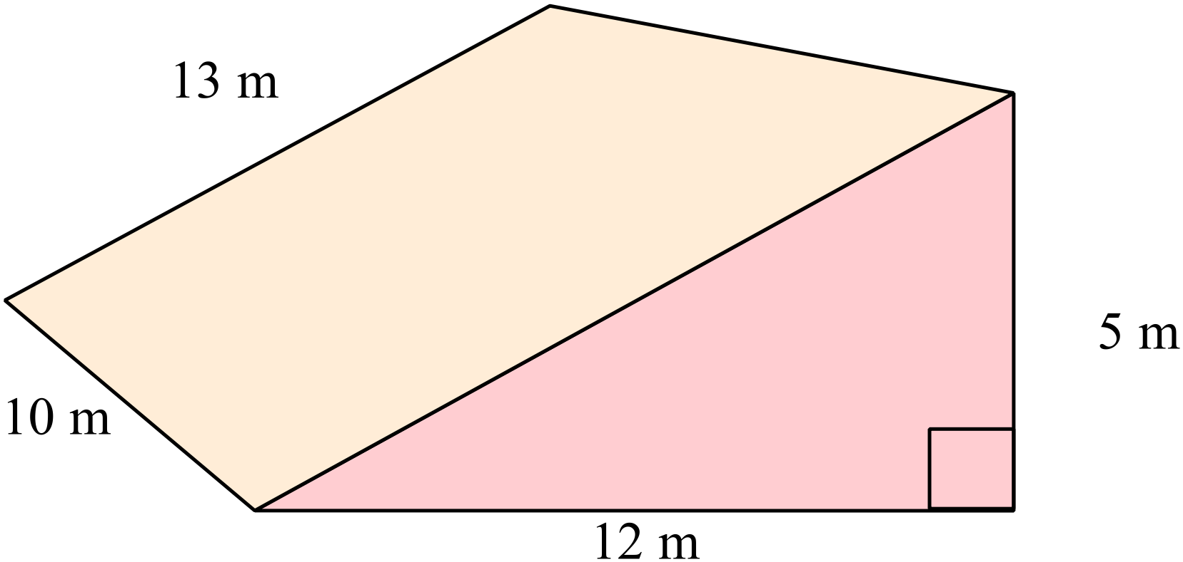What is the volume of the prism shown?

………………………………………………

……………………………………………....

………………………………………………

……………………………………………....
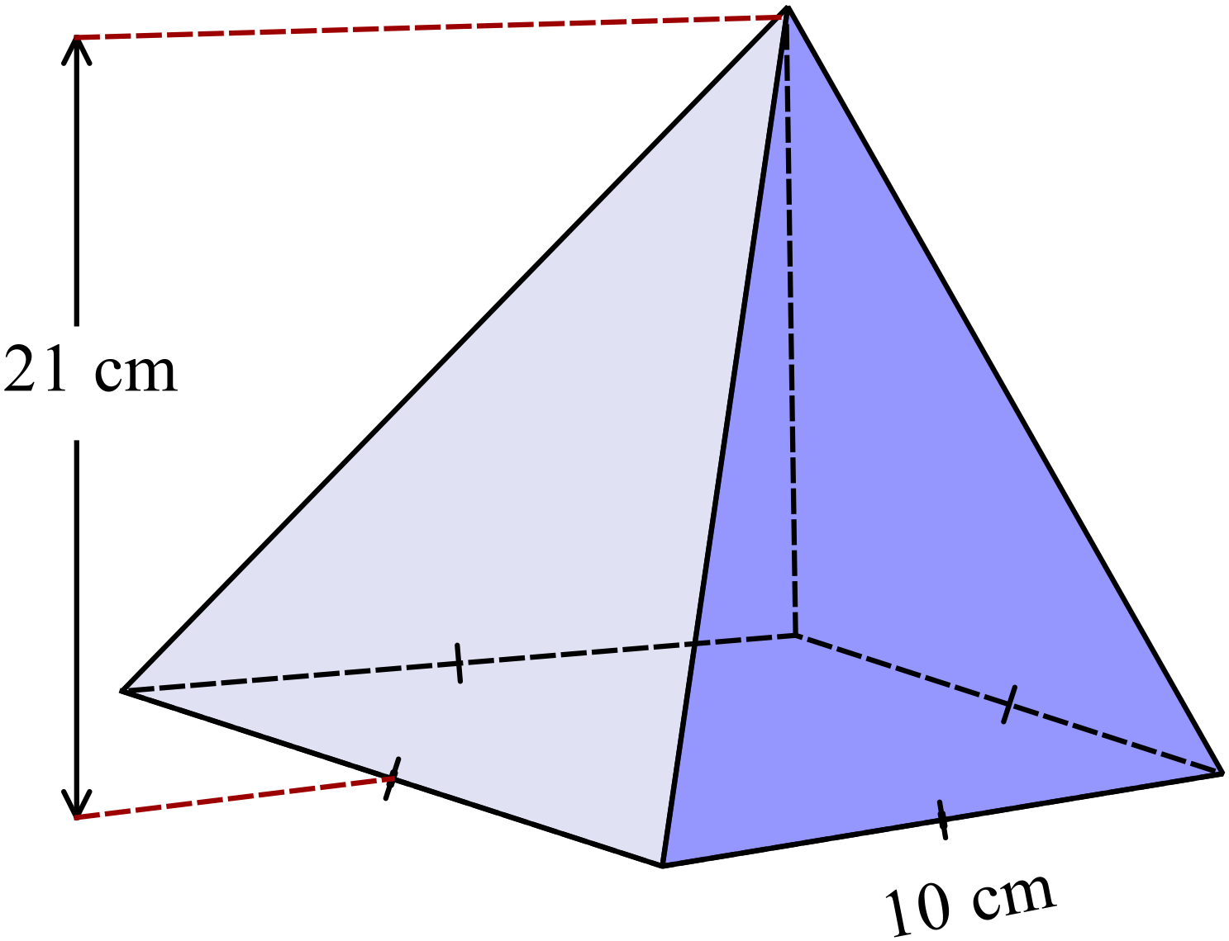What is the volume of the square pyramid?

………………………………………………

……………………………………………....

………………………………………………

……………………………………………....
A rectangular pyramid has base edges 15 cm and 10 cm and a perpendicular of height 8 cm.
What is its volume?

……………………………………………………………………………………………....

……………………………………………………………………………………………....
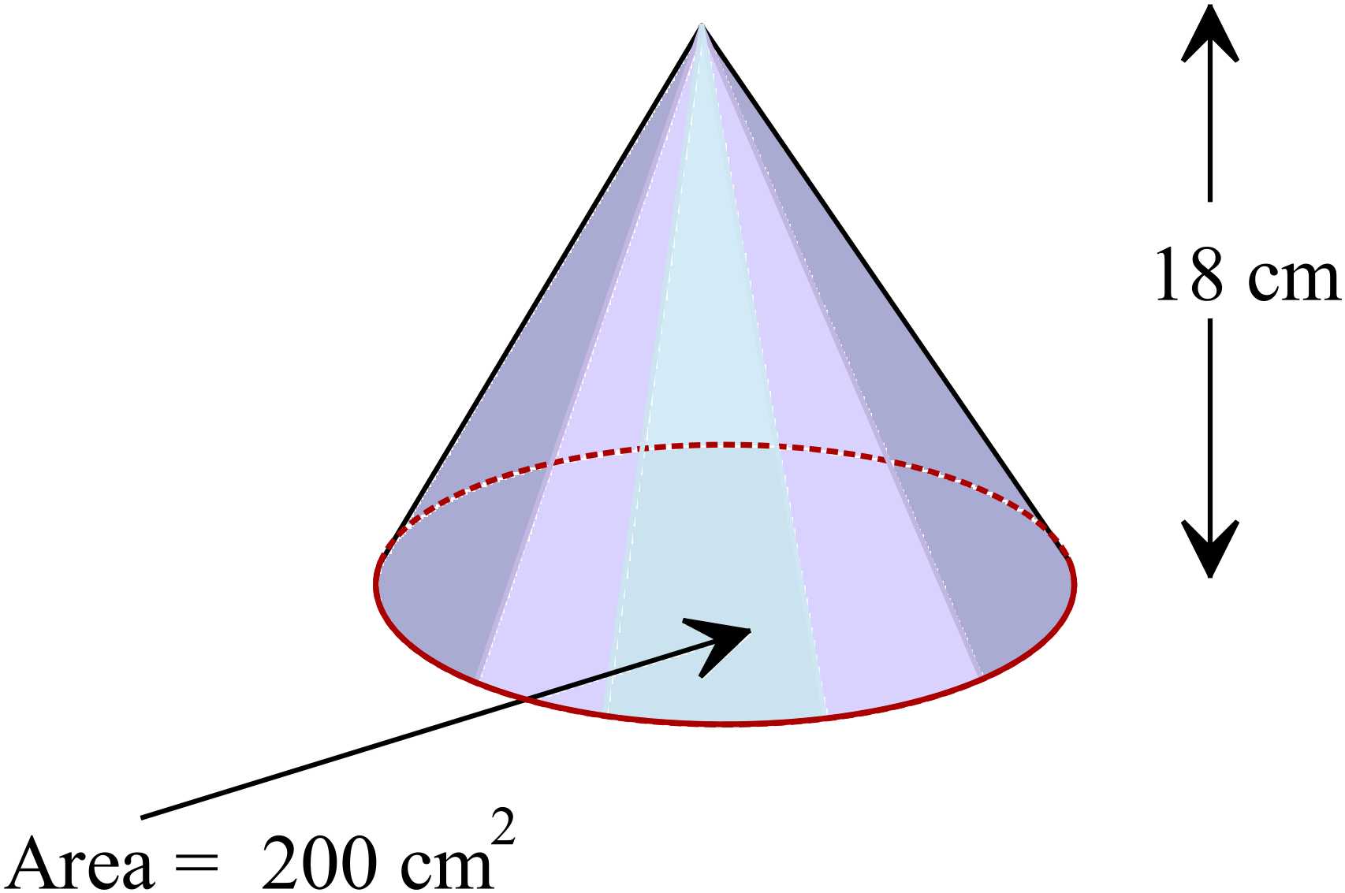A cone has a height of 18 cm and the area of its base is 200 cm².
What is its volume?

………………………………………………

……………………………………………....

………………………………………………

……………………………………………....
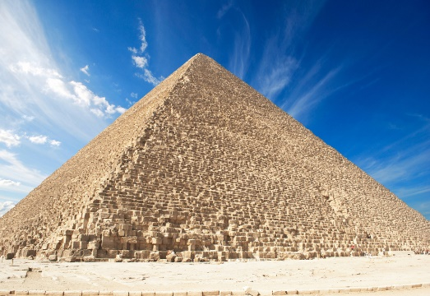
An Egyptian pyramid has a square base 120 m long and the slant height of each face is 80 m.
What is the surface area of its exposed faces?

………………………………………………

……………………………………………....

………………………………………………

……………………………………………....
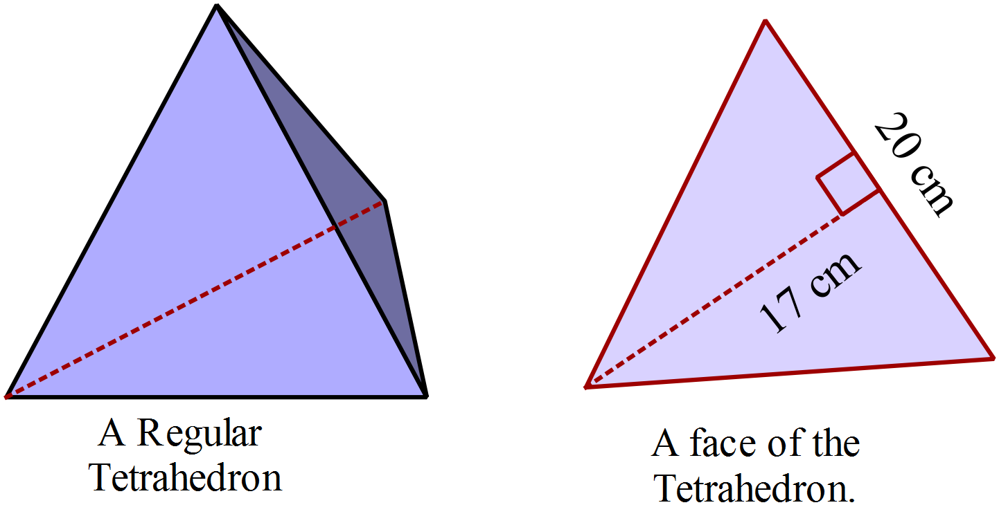A regular tetrahedron has 4 congruent triangular faces with the dimensions (to the nearest half cm) shown on the diagram.
What is the surface area of the regular tetrahedron?

……………………………………………....

………………………………………………

……………………………………………....
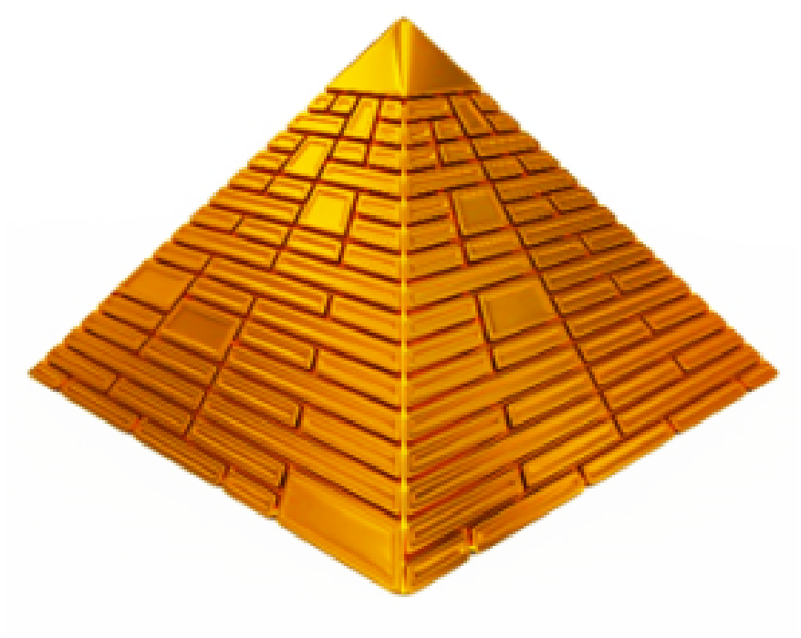Joan wants to make a square pyramid as shown.
Its base measures 30 cm along each side.
She wants the volume to be 12 000 cm³.
What height should she make the pyramid?

……………………………………………....

………………………………………………

……………………………………………....
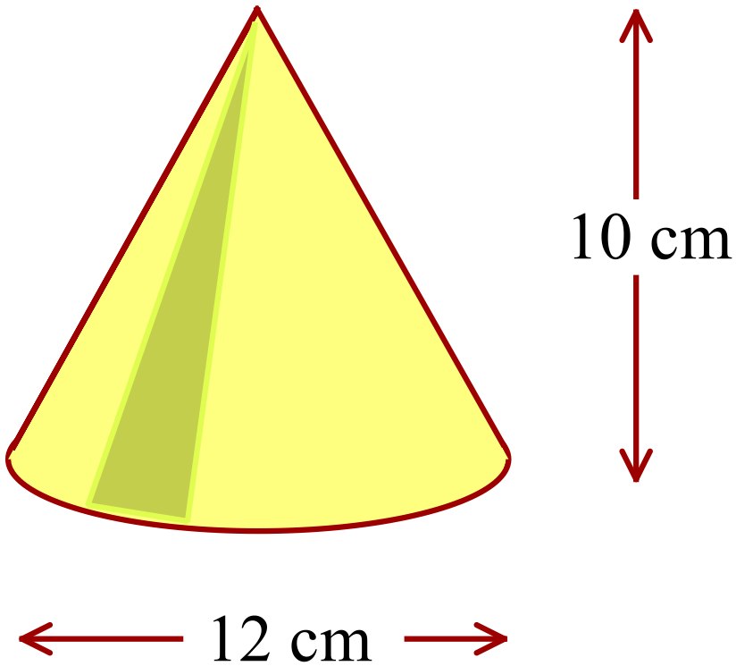What is the volume of this cone?
Answer in terms of 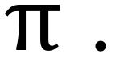

………………………………………………

……………………………………………....

………………………………………………

……………………………………………....
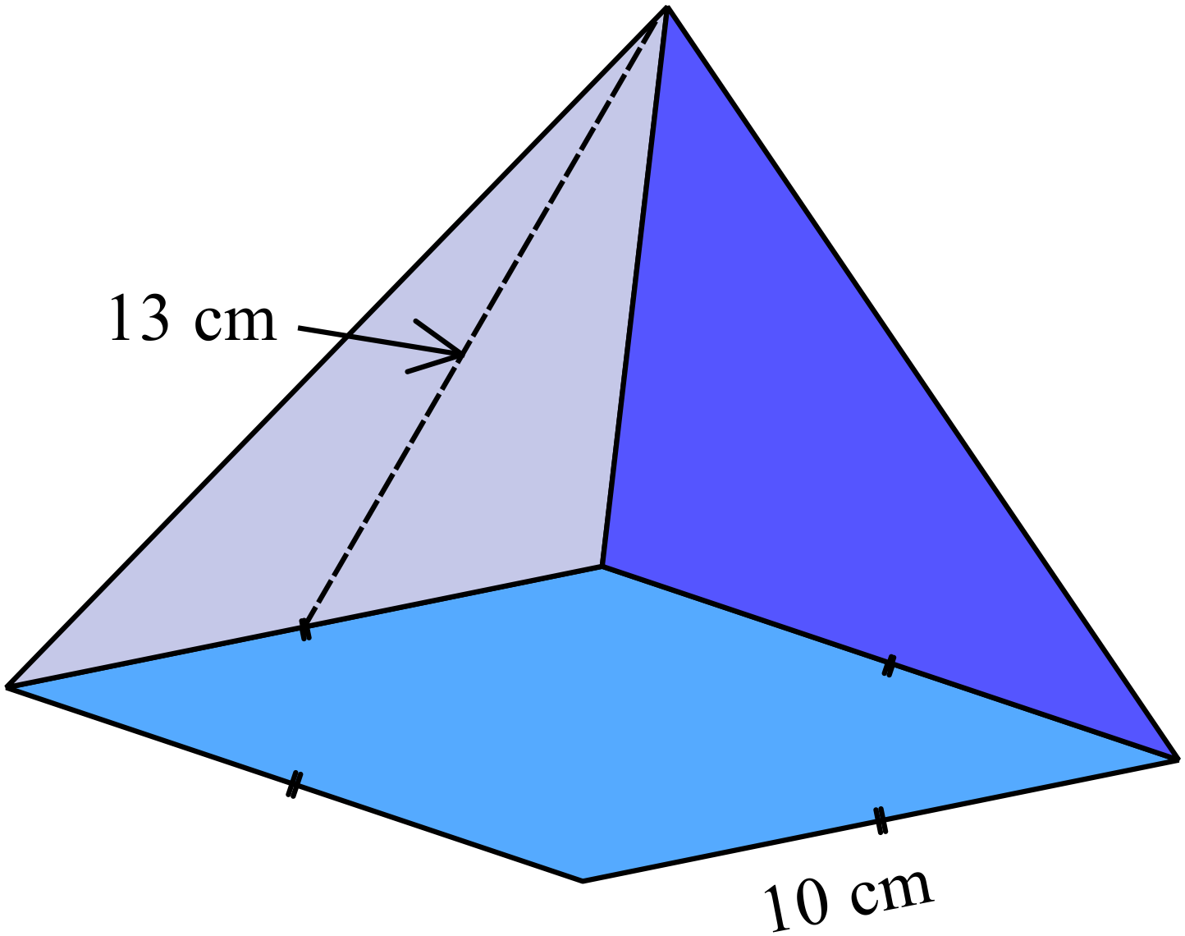What is the surface area of the square pyramid shown?

………………………………………………

……………………………………………....

………………………………………………

……………………………………………....
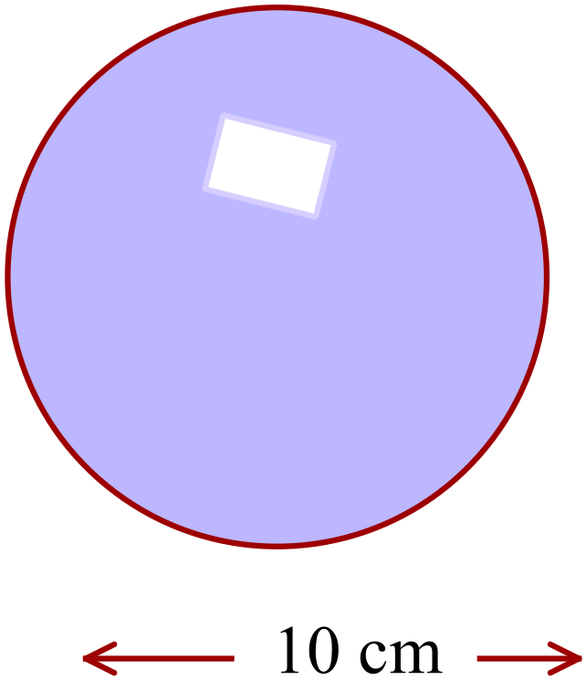What is the surface area of the sphere?
Answer in terms of

………………………………………………

……………………………………………....

………………………………………………

……………………………………………....
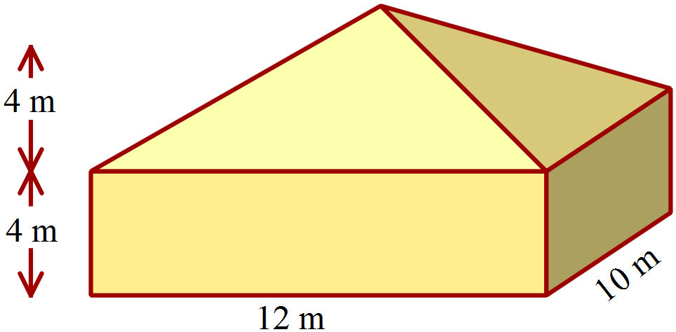What is the volume of the building shown?

………………………………………………

……………………………………………....

………………………………………………

……………………………………………....
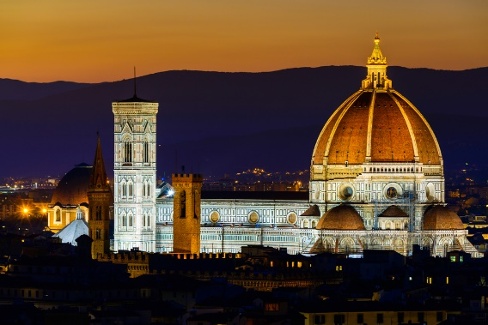
The dome on a cathedral in Florence can be approximated by a hemisphere of diameter 44 metres.
What is the surface area of the dome (in terms of 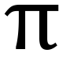)?

……………………………………………....

………………………………………………

……………………………………………....
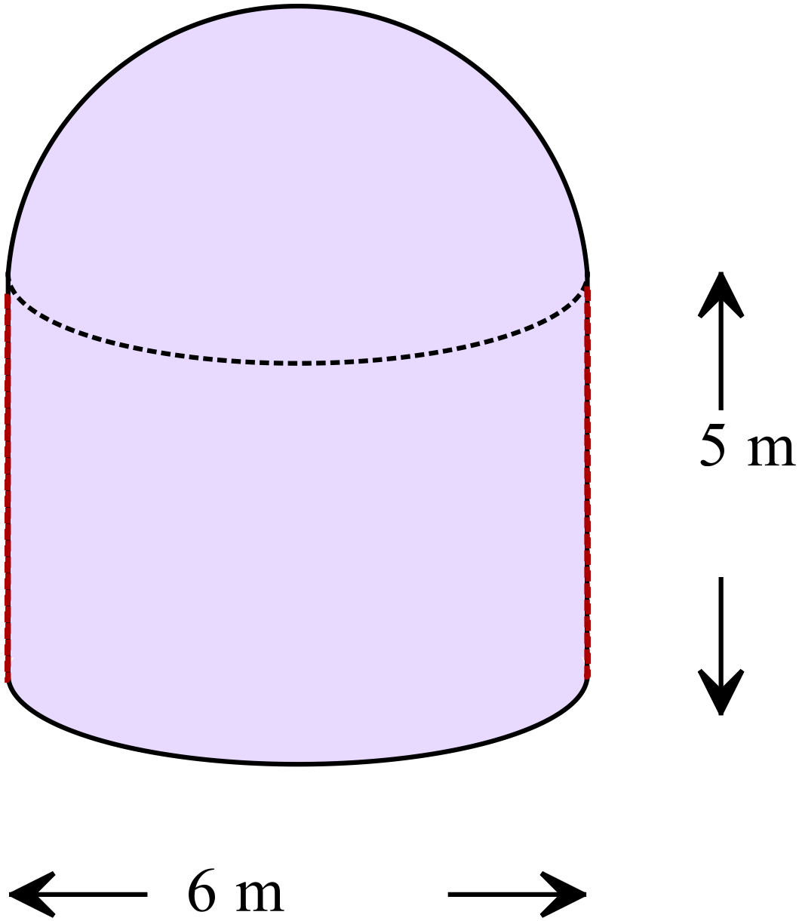The building was designed to house an observatory and has cylindrical walls and a hemispherical roof.
Ignoring the thickness of the walls, what is the volume of the building in terms of ?

………………………………………………

……………………………………………....

………………………………………………

……………………………………………....
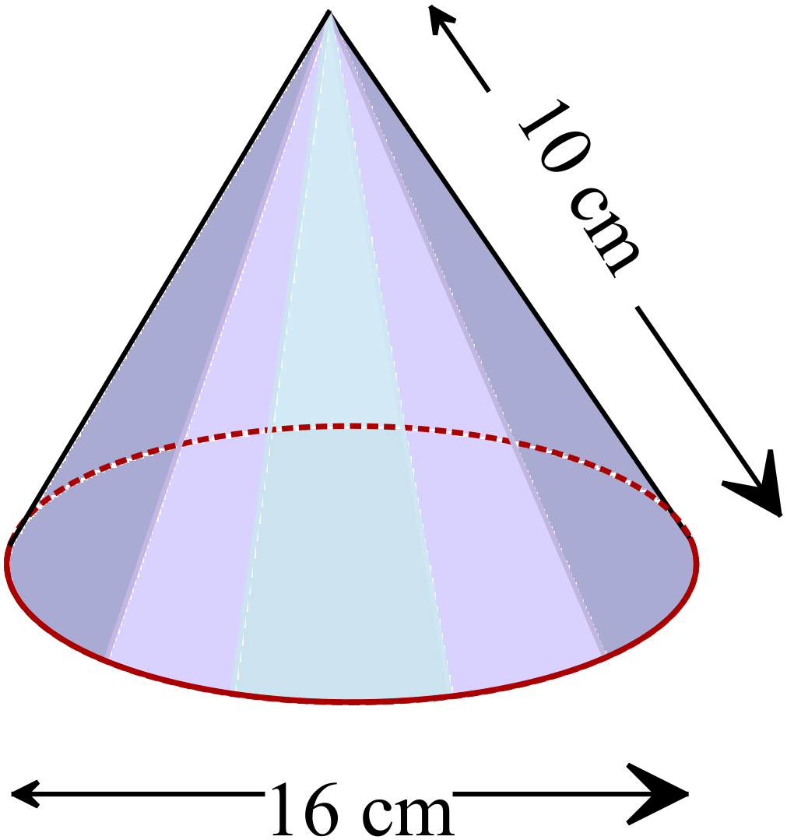What is the surface area of this cone, in terms of ?

………………………………………………

……………………………………………....

………………………………………………

……………………………………………....
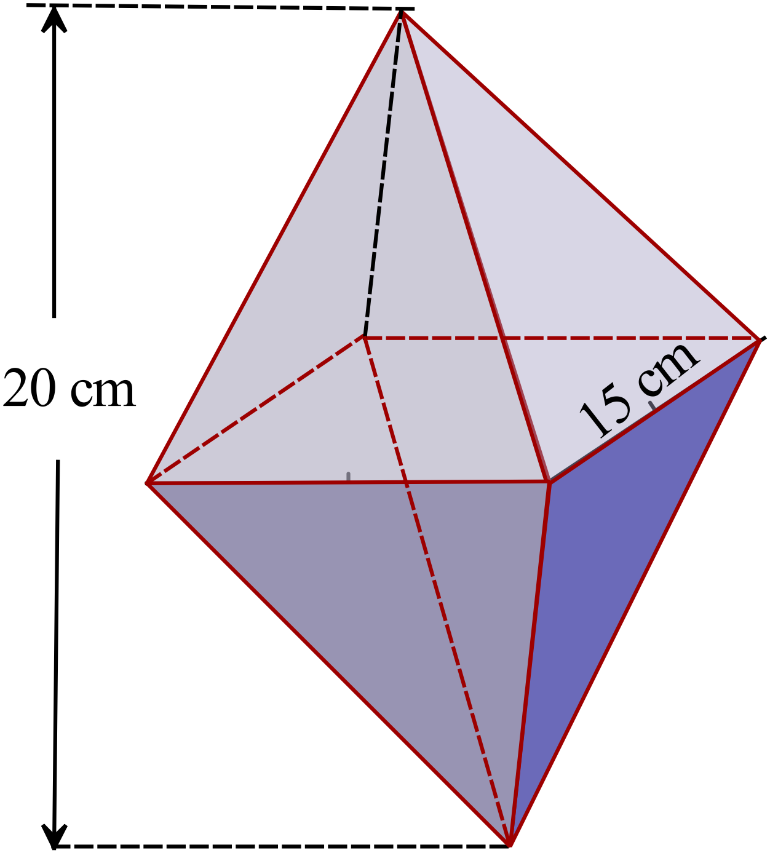The octahedron shown consists of two identical square pyramids, joined at their bases
What is the volume of the octahedron?

………………………………………………

……………………………………………....

………………………………………………

……………………………………………....

Year 10 |  | Surface Area and Volume of Other Solids | Calculator Allowed
 |  | Surface Area and Volume of Other Solids | Name_________________
Section 2 Multiple Choice Section
Mark all your answers on the accompanying multiple choice answer sheet, not on this test paper. You may do any working out on this test paper. Calculators are allowed for this section.

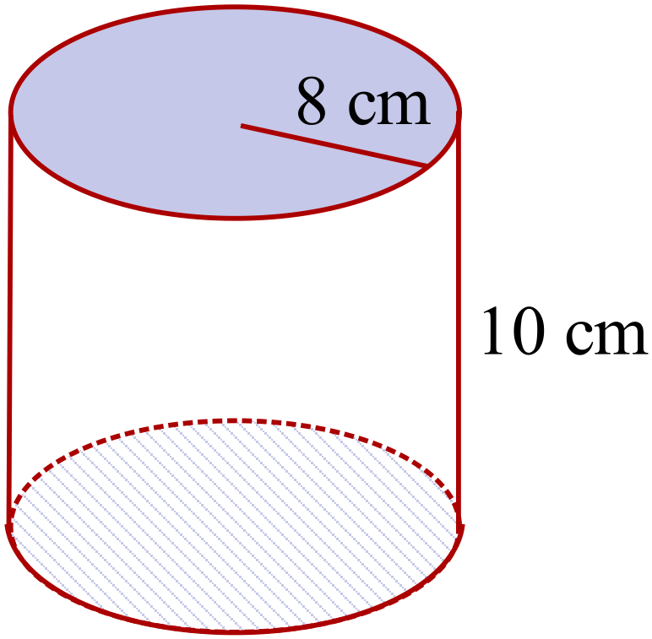Find the volume of the cylinder shown (to the nearest cm).

A. 670 cm³
B. 2 011 cm³
C. 2 145 cm³
D. 8 042 cm³

A triangular pyramid has a perpendicular height of 6 cm and its base has an area of 30 cm².
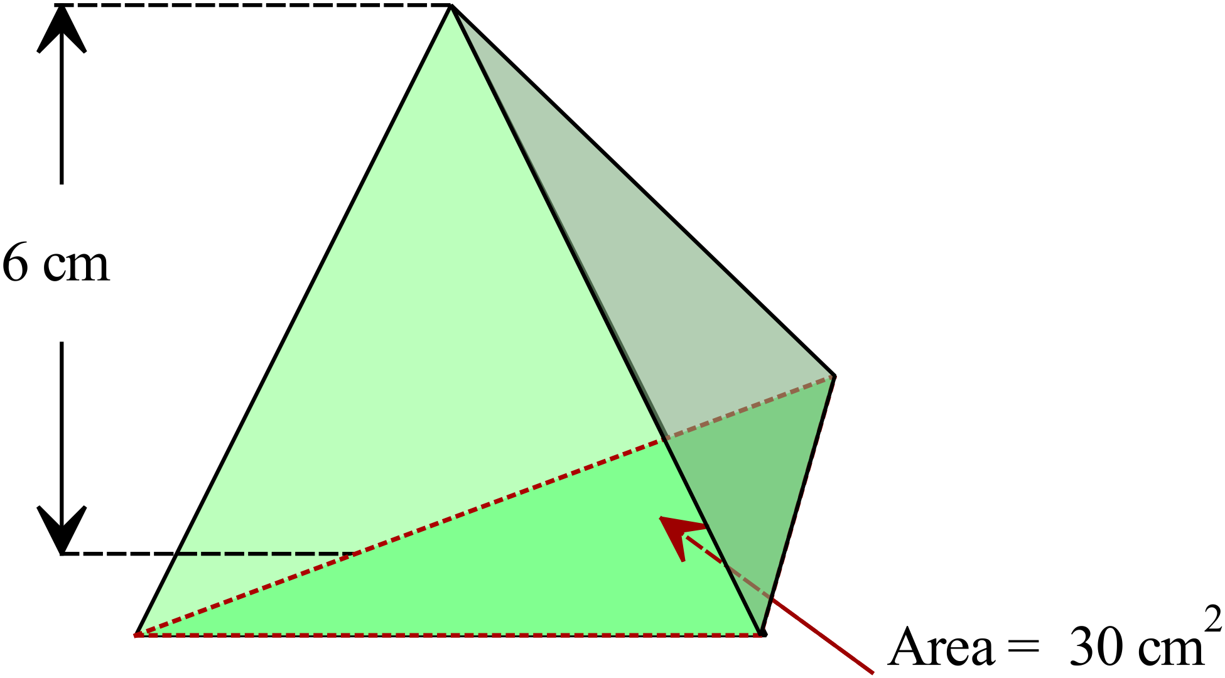What is its volume?

A. 30 cm³
B. 33 cm³
C. 60 cm³
D. 90 cm³

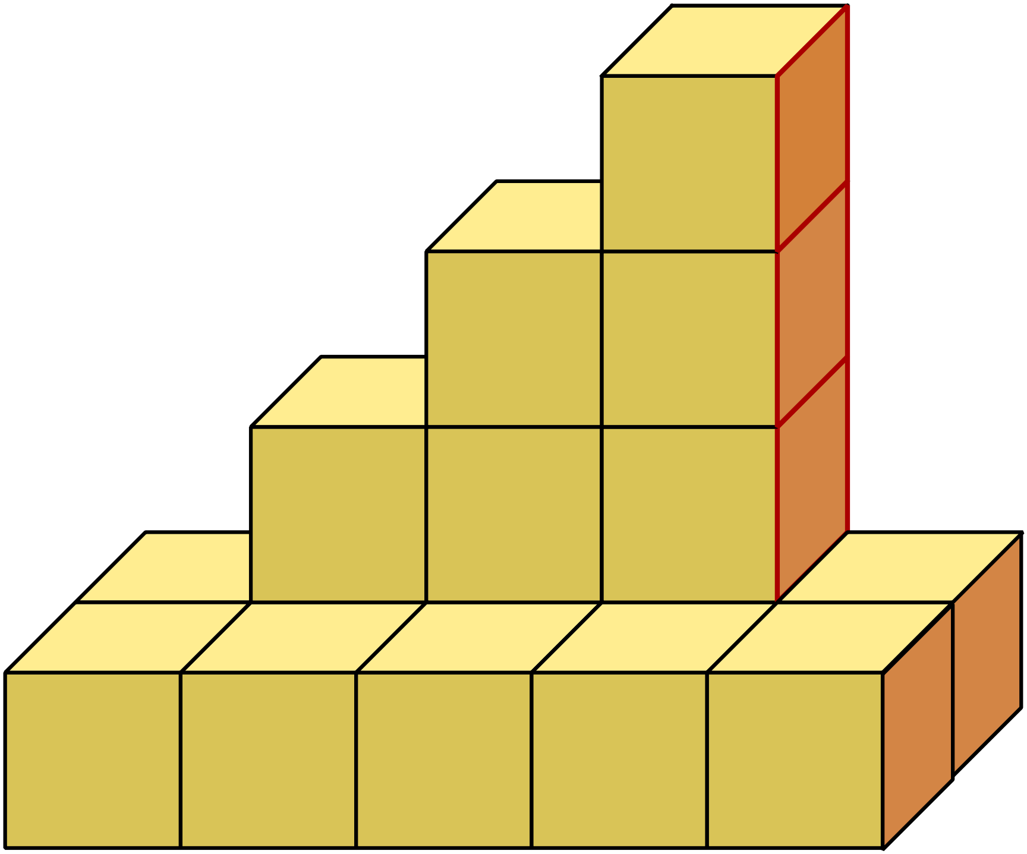This solid is made by stacking cubes which measure 5 cm along each edge.
What is the total volume of the solid formed?

A. 400 cm³
B. 800 cm³
C. 1000 cm³
D. 2000 cm³
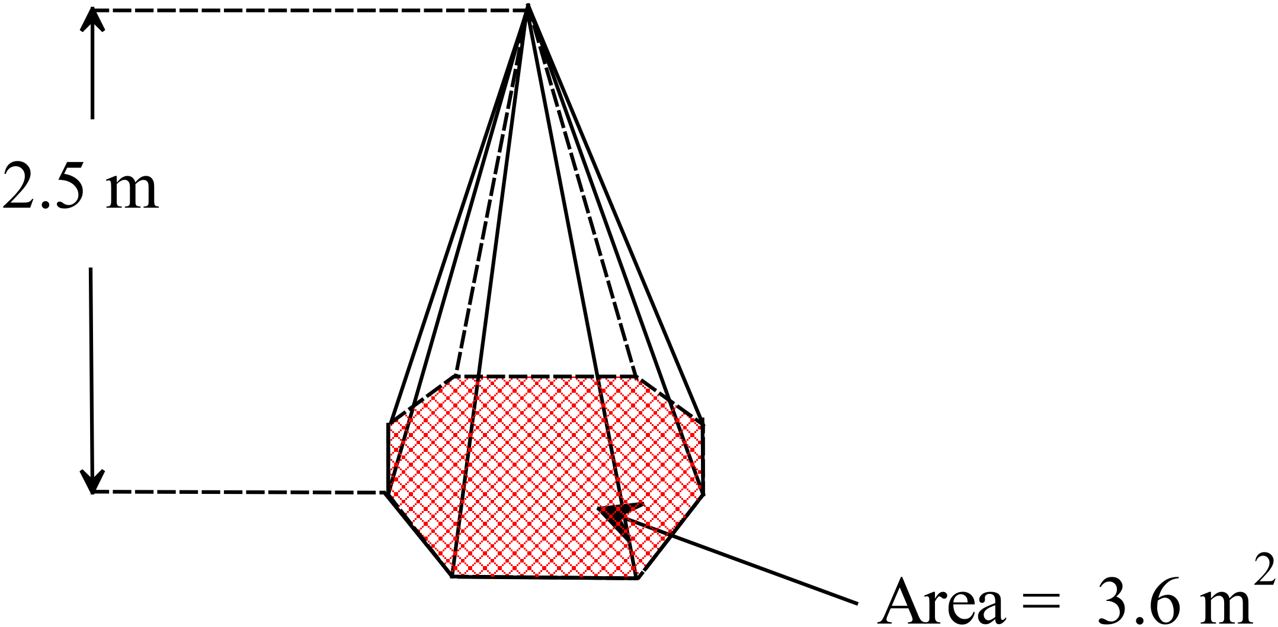The octagonal pyramid is 2.5 m high and its base has an area of 3.6 m².
Find its volume.
A. 3.0 cm³
B. 4.5 cm³
C. 5.25 cm³
D. 9.0 cm³

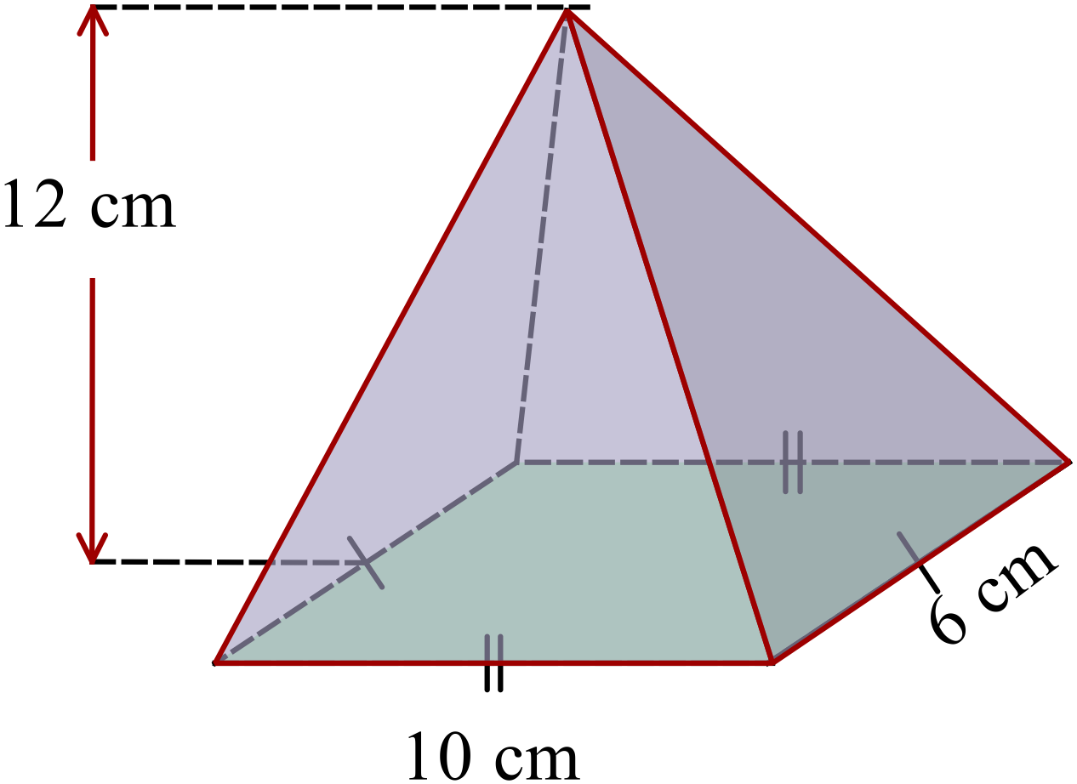What is the volume of the rectangular pyramid?

A. 96 cm³
B. 240 cm³
C. 360 cm³
D. 720 cm³

What is the volume of a sphere which has a radius of 2.5 metres?

A. 16 m³ B. 49 m³ C. 65 m³ D. 196 m³
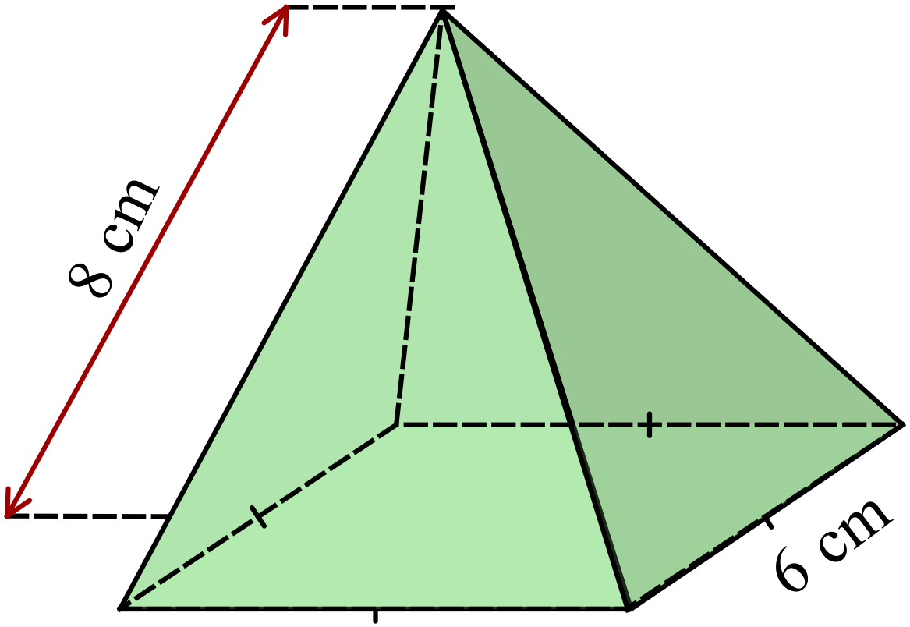What is the surface area of the square pyramid?

A. 132 cm²
B. 156 cm²
C. 264 cm²
D. 312 cm²
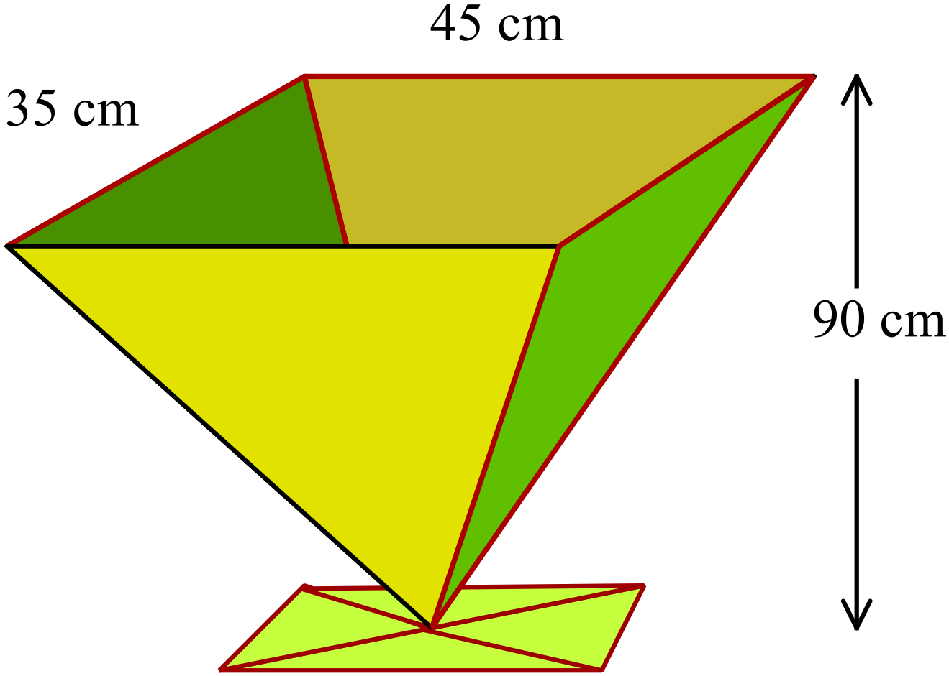A large vase is in the shape of a rectangular pyramid.
How many litres of water can it hold?
1000 cm³ holds 1 litre of water.

A. 3.6 litres
B. 47.25 litres
C. 70.88 litres
D. 141.75 litres
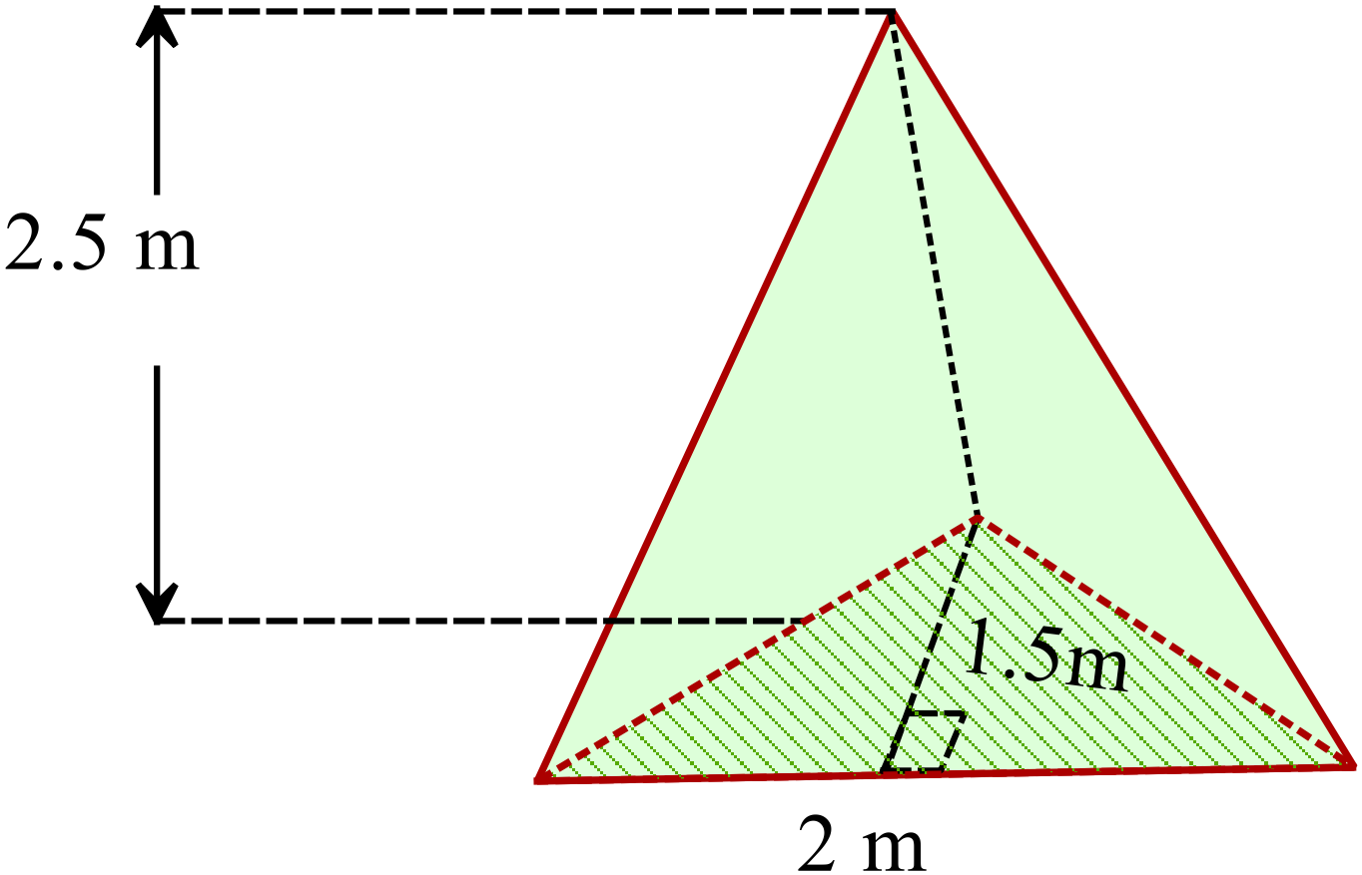Calculate the volume of the triangular prism shown.

A. 1.25 m³
B. 2.5 m³
C. 3.75 m³
D. 4.375 m³

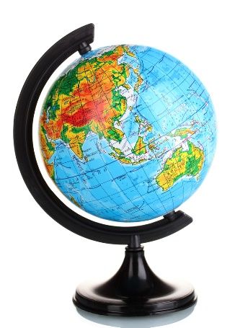
A globe of the earth is a 20 cm diameter sphere.
What is the surface area of the globe?

A. 314 cm²
B. 471 cm²
C. 628 cm²
D. 1 257 cm²

What is the surface area of the square pyramid shown?
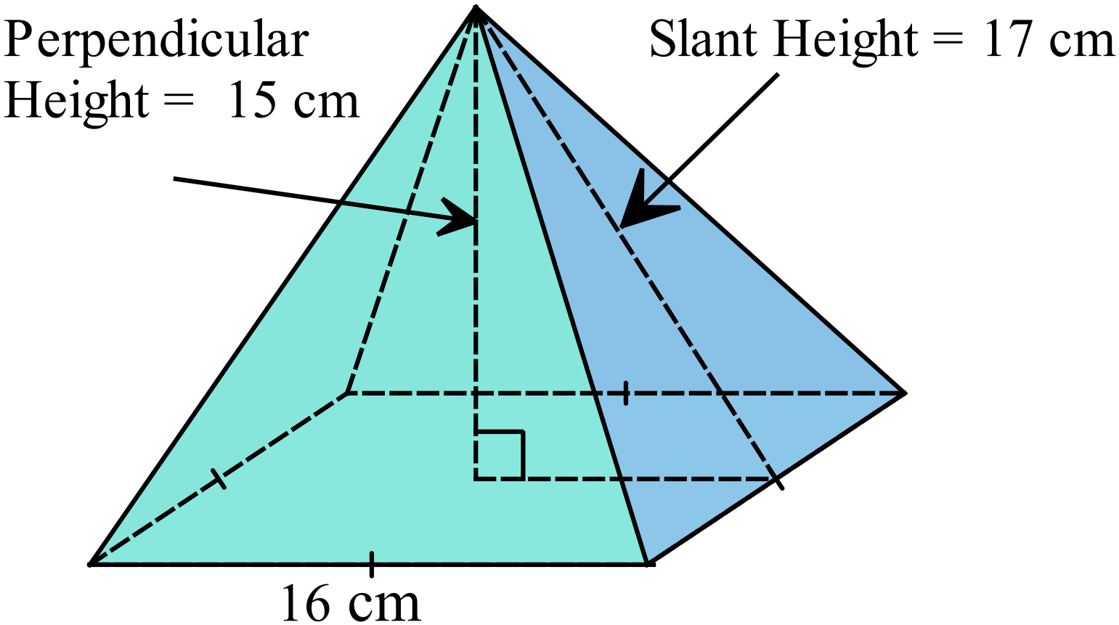

A. 672 cm²
B. 767 cm²
C. 800 cm²
D. 1 280 cm²
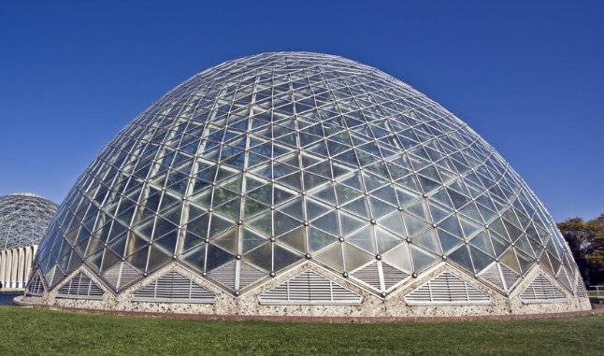
A glasshouse is a geodesic dome, which is approximately the size of a hemisphere with a diameter of 25 metres.
What is the approximate area of glass that would be needed for the glasshouse?

A. 157 m²
B. 981 m²
C. 1953 m²
D. 1963 m²
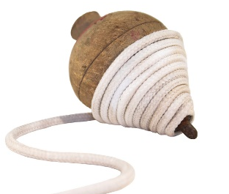
The design for a solid wooden spinning top is in the shape of a cone topped by a hemisphere and then a smaller cylinder.

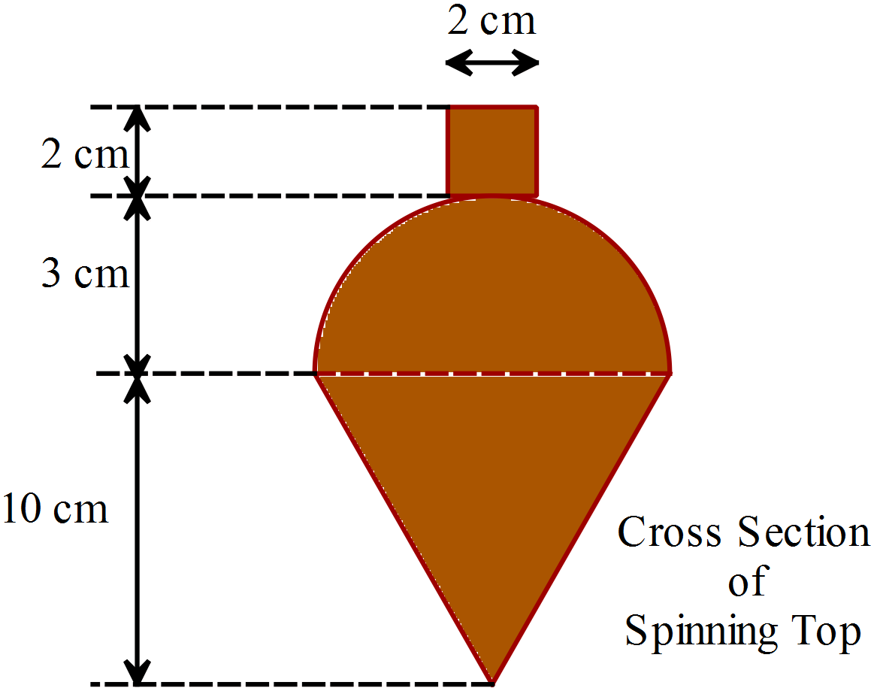A cross section of the spinning top is shown with its dimensions given.

What is the volume of the spinning top?

A. 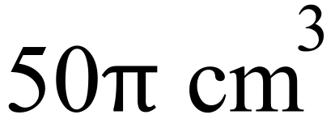
B. 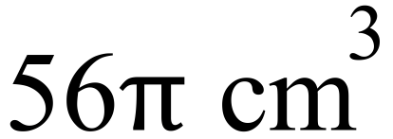
C. 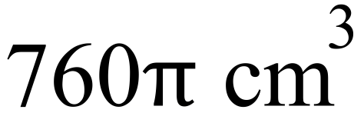
D. 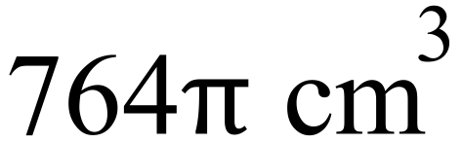
A hemisphere has a volume of 2.5 m³.
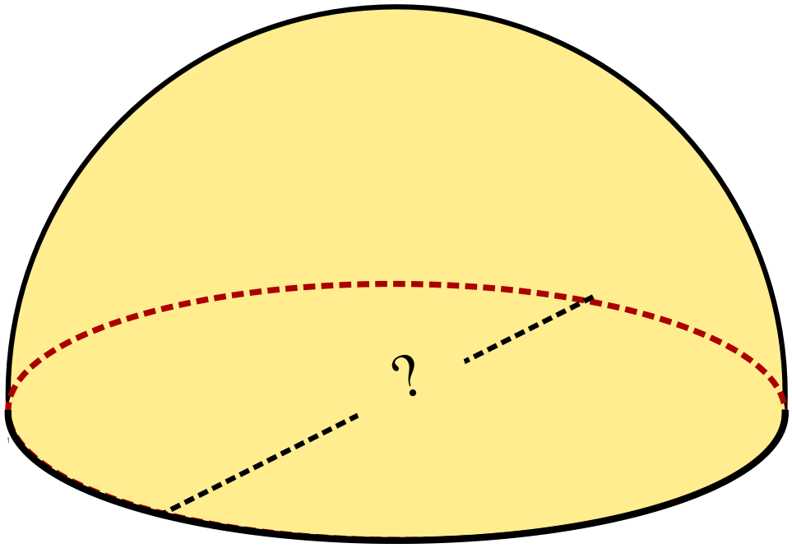What is its diameter, to the nearest cm?

A. 0.56 m
B. 1.06 m
C. 2.12 m
D. 7.50 m
The solid shown is formed by cutting the top 8 cm in height from a square pyramid which originally had a height of 16 cm and a base with sides of 12 cm.
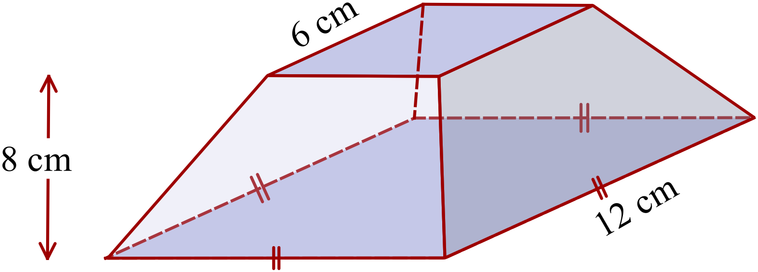What is the volume of the truncated pyramid?

A. 96 cm³
B. 127 cm³
C. 384 cm³
D. 672 cm³

Year 10 | Surface Area and Volume of Other Solids | Calculator Allowed
Year 10 | Surface Area and Volume of Other Solids | Name___________________
Section 3 Longer Answer Section
Write all working and answers in the spaces provided on this test paper.

 |  | Marks
1. | The square pyramid below has a base which measures 66 cm and a perpendicular height of 56 cm.  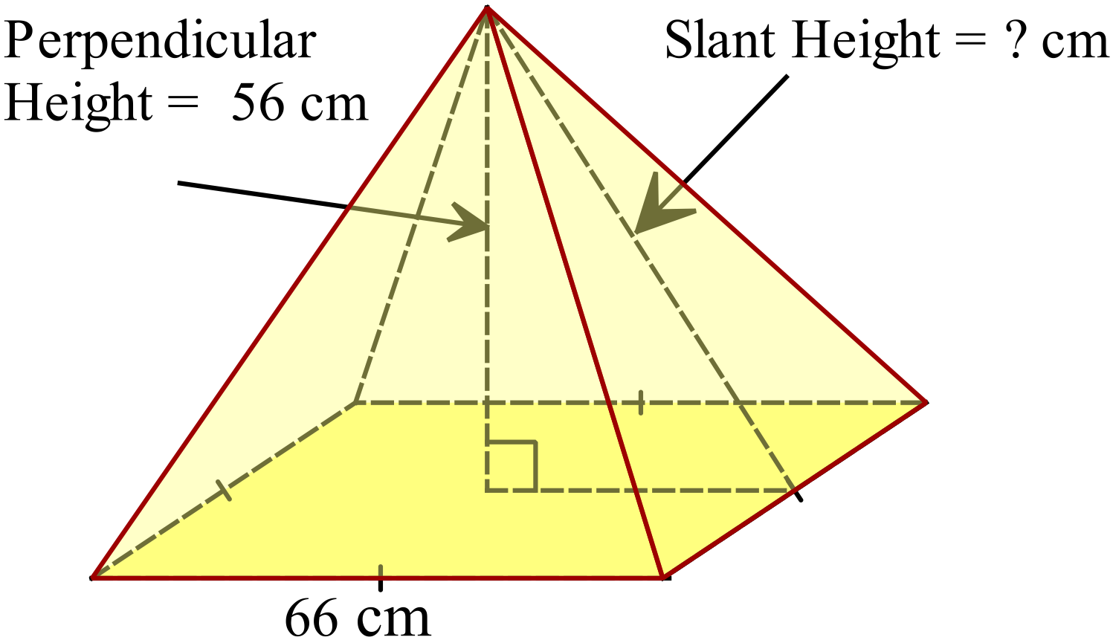
 | (a) Calculate the volume of the pyramid.  ……………………………………………………………………………………..  …………………………………………………………………………………….. | 1
 | (b) Calculate the slant height of the pyramid.  ……………………………………………………………………………………..  …………………………………………………………………………………….. | 1
 | (c) Calculate the surface area of the pyramid.  ……………………………………………………………………………………..  …………………………………………………………………………………….. | 2

Multiple Choice Answer Sheet
Surface Area and Volume of Other Solids
Name _____________________________________________
Completely fill the response oval representing the most correct answer.

1. A B C D
2. A B C D
3. A B C D
4. A B C D
5. A B C D
6. A B C D
7. A B C D
8. A B C D
9. A B C D
10. A B C D
11. A B C D
12. A B C D
13. A B C D
14. A B C D
15. A B C D
Year 10 |  | Surface Area and Volume of Other Solids | Non Calculator
Section 1 Short Answer Section
ANSWERS
No. | WORKING |  | ANSWER
 | 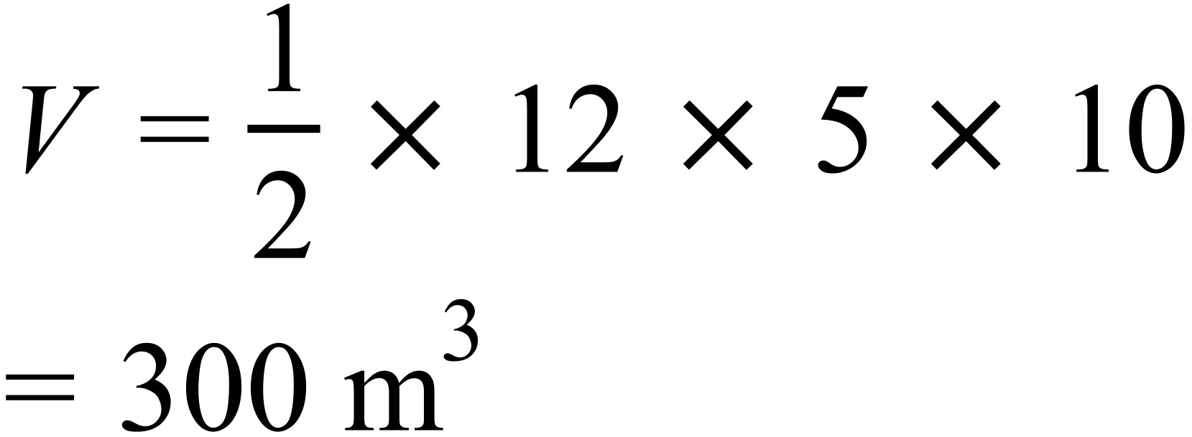 |  | 300 m³
 | 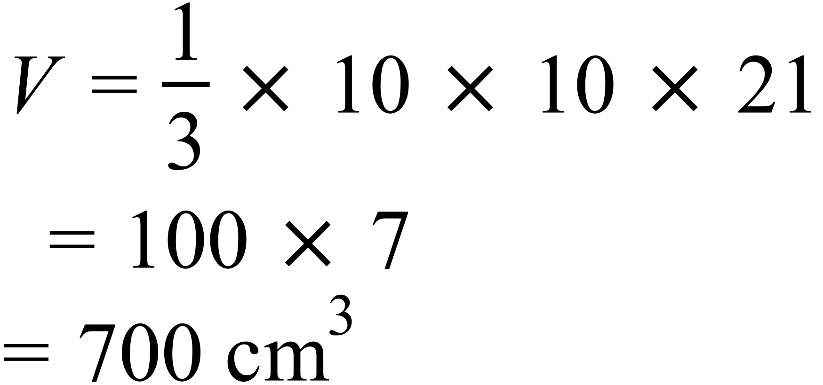 |  | 700 cm³
 | 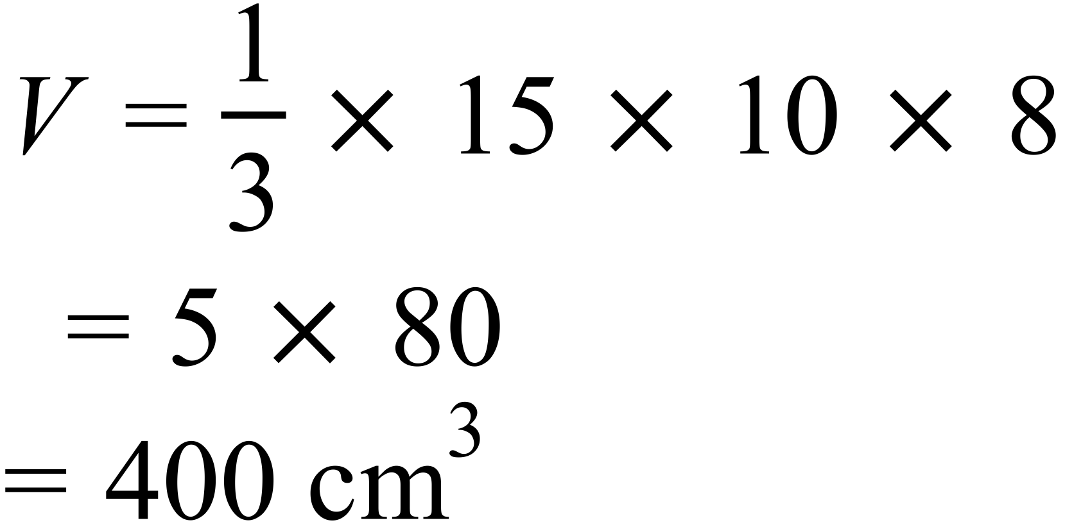 |  | 400 cm³
 | 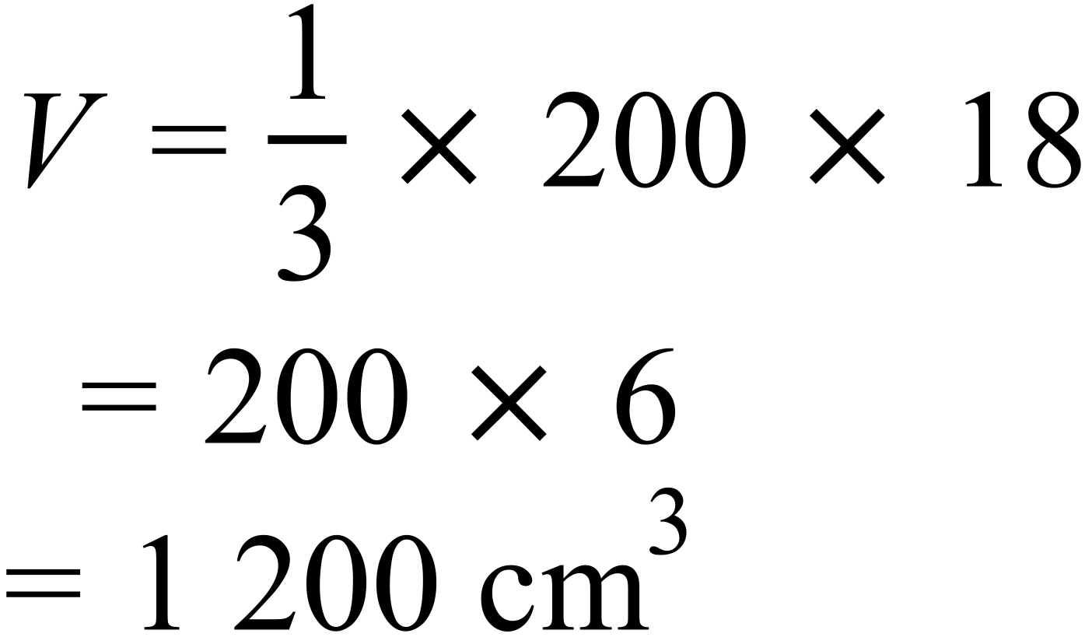 |  | 1 200 cm³
 | 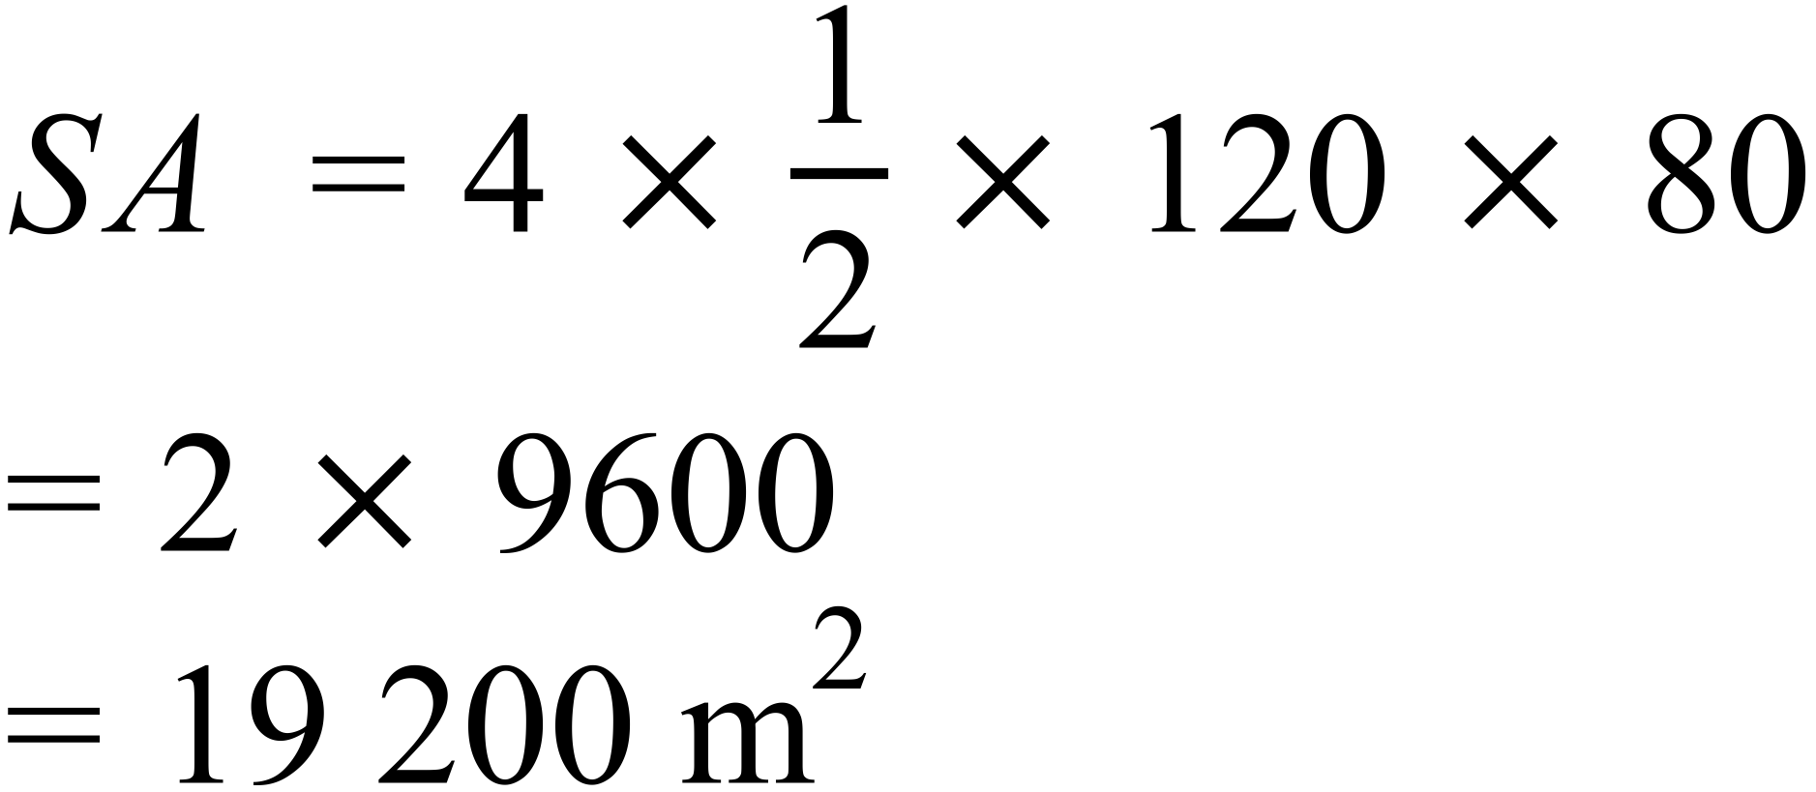 |  | 19 200 m²
 | 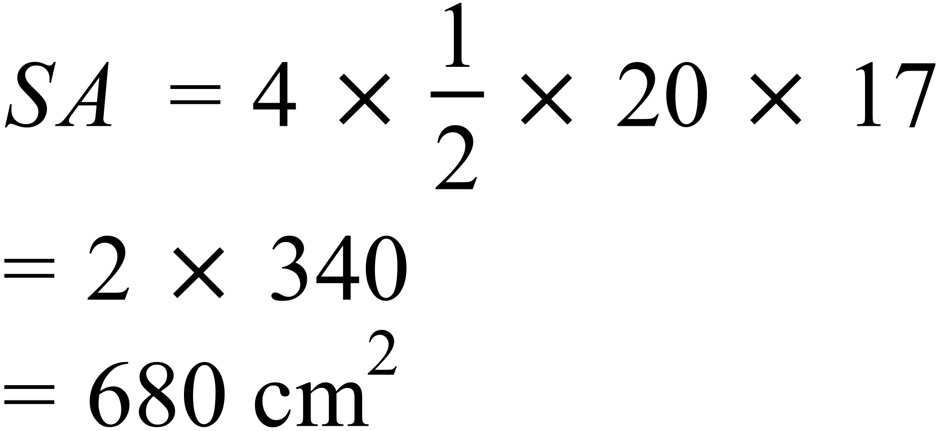 |  | 680 cm²
 | 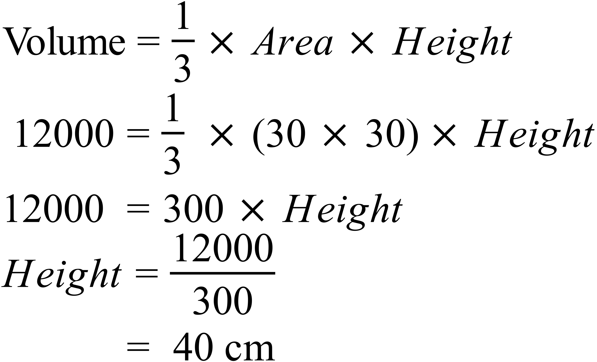 |  | 40 cm
 | 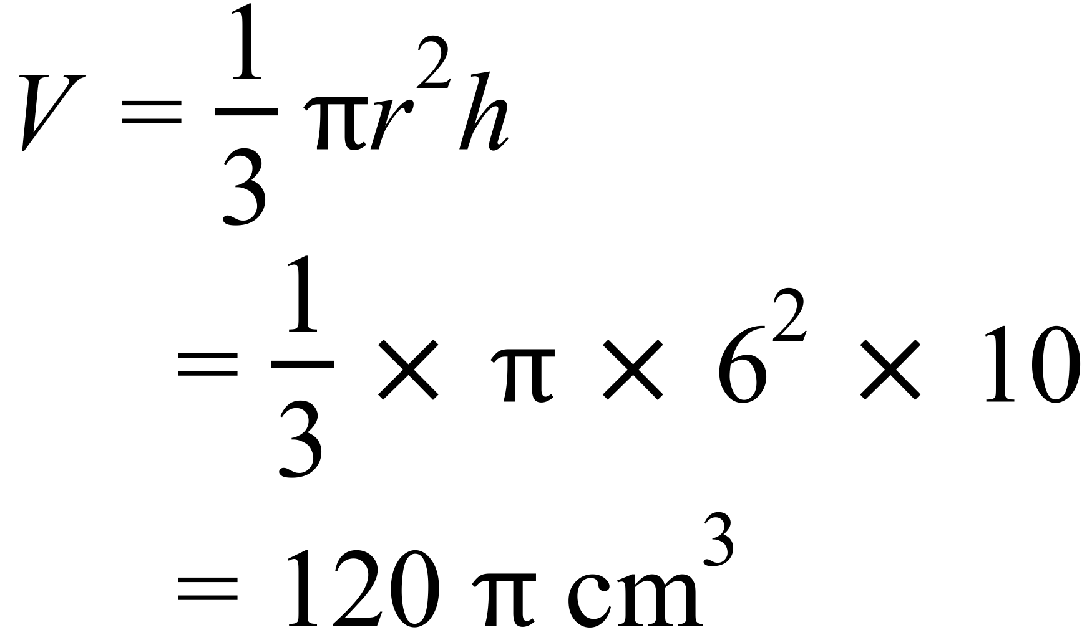 |  | 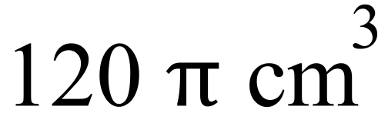
 | 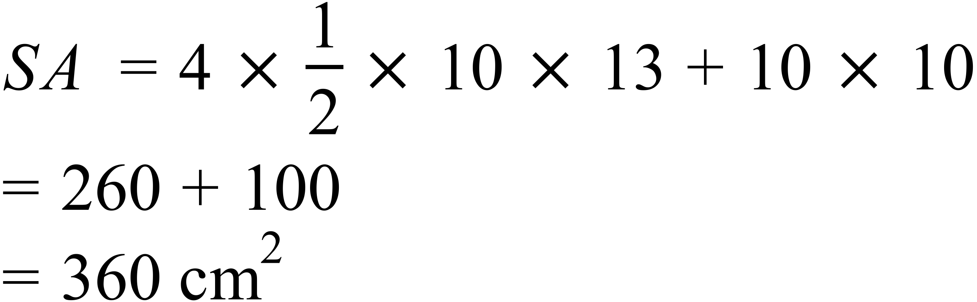 |  | 360 cm²
 | 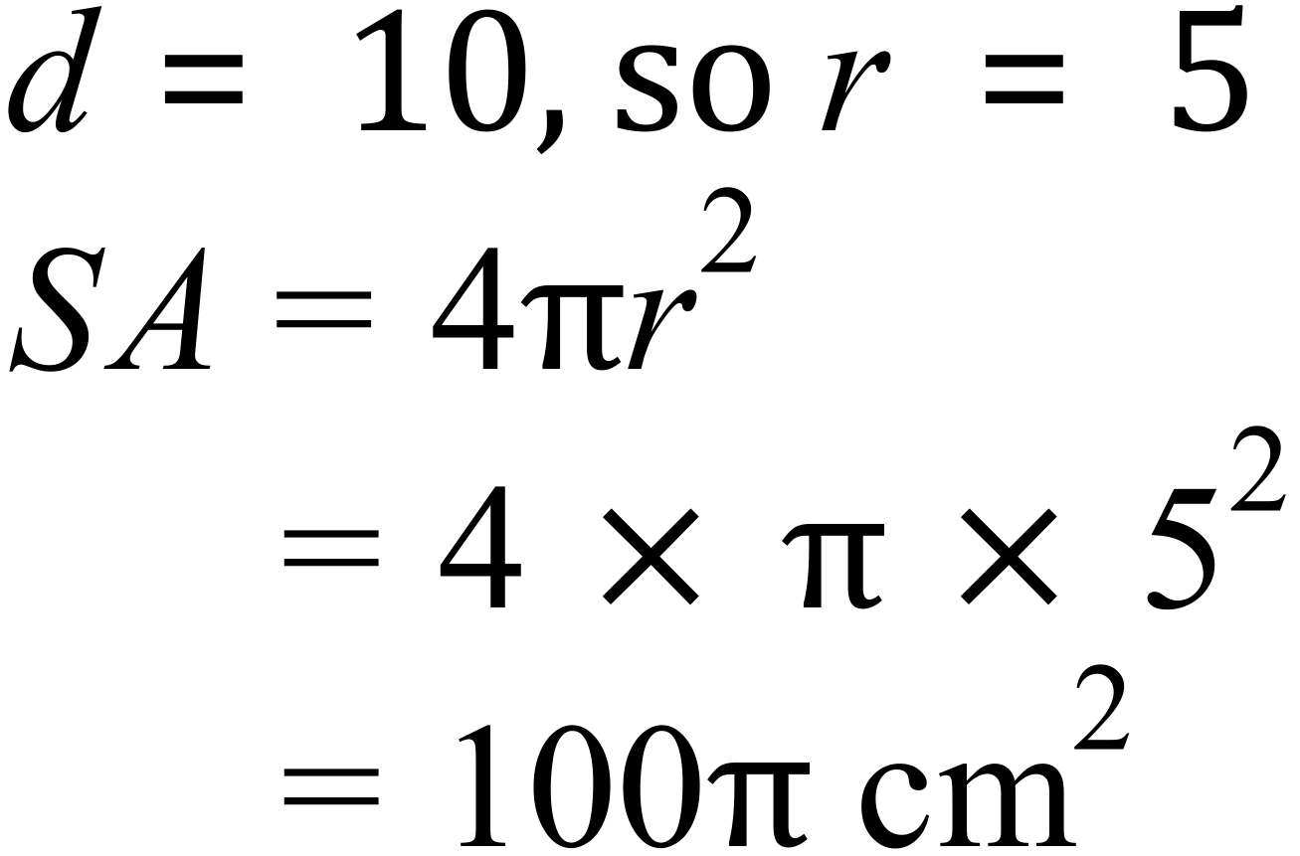 |  | 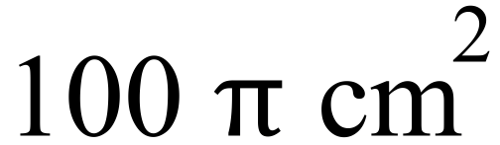
 | 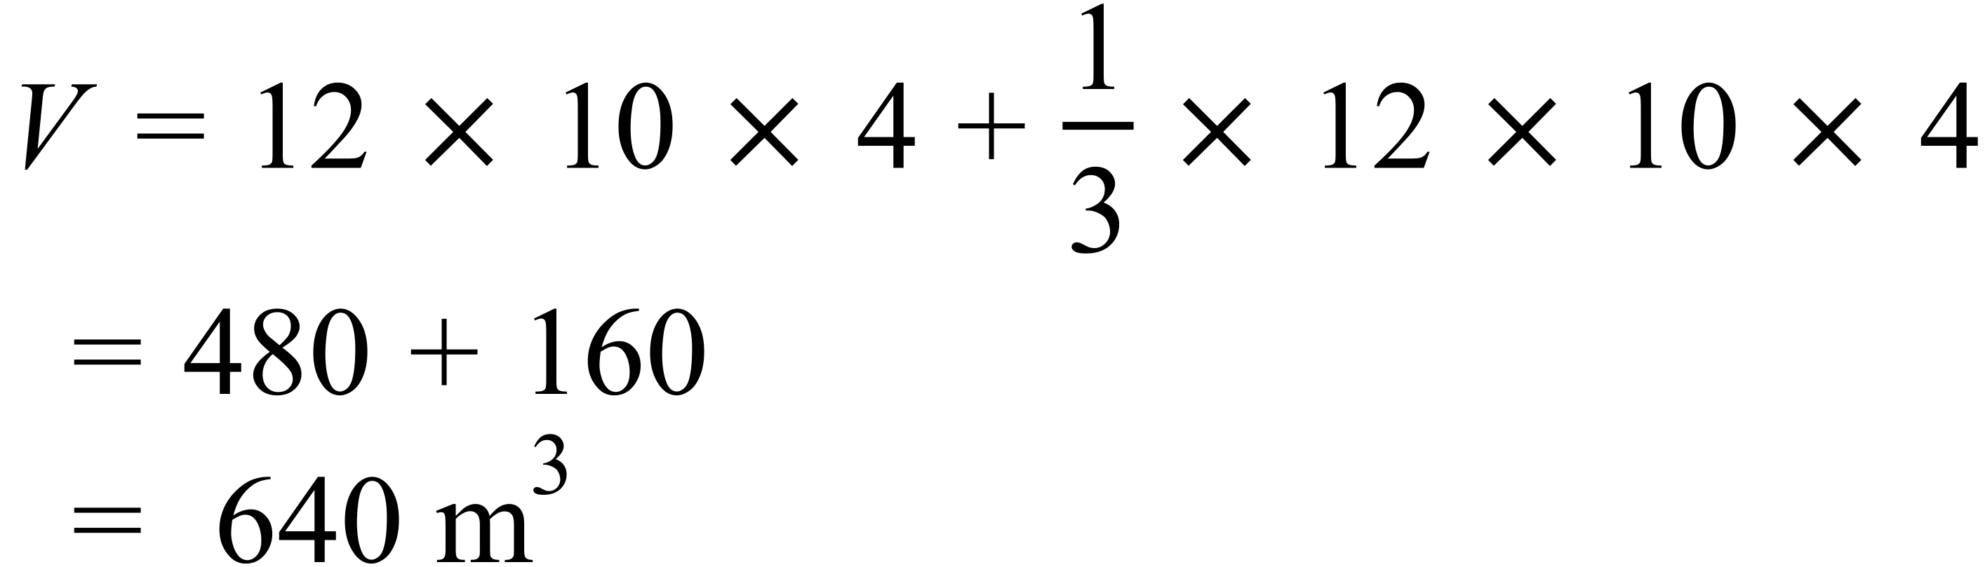 |  | 640 m³
 | 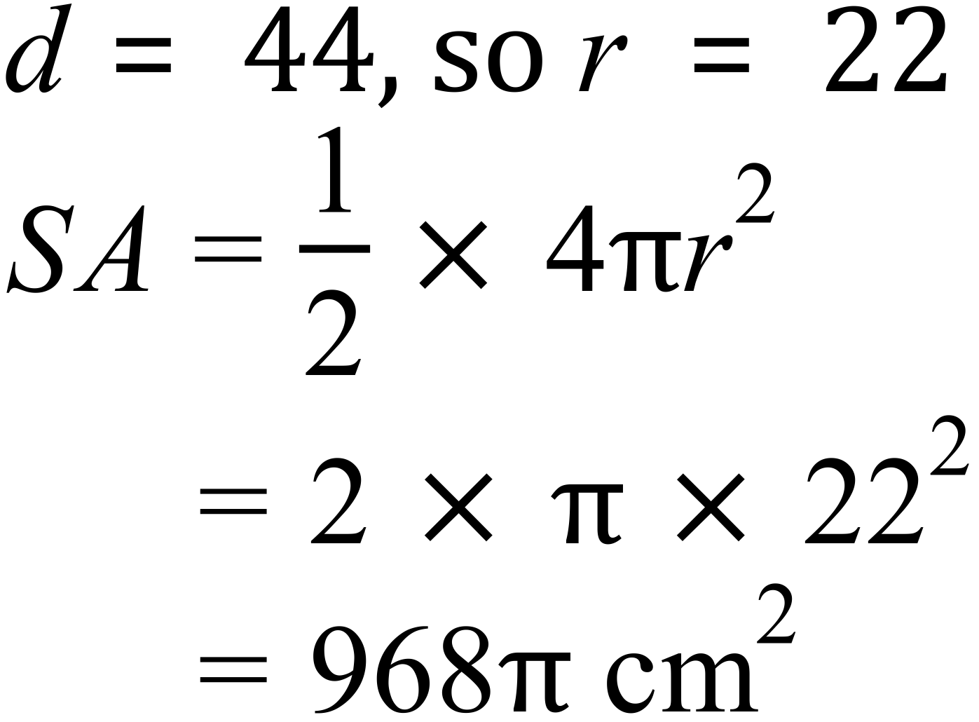 |  | 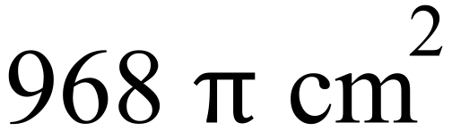
 | 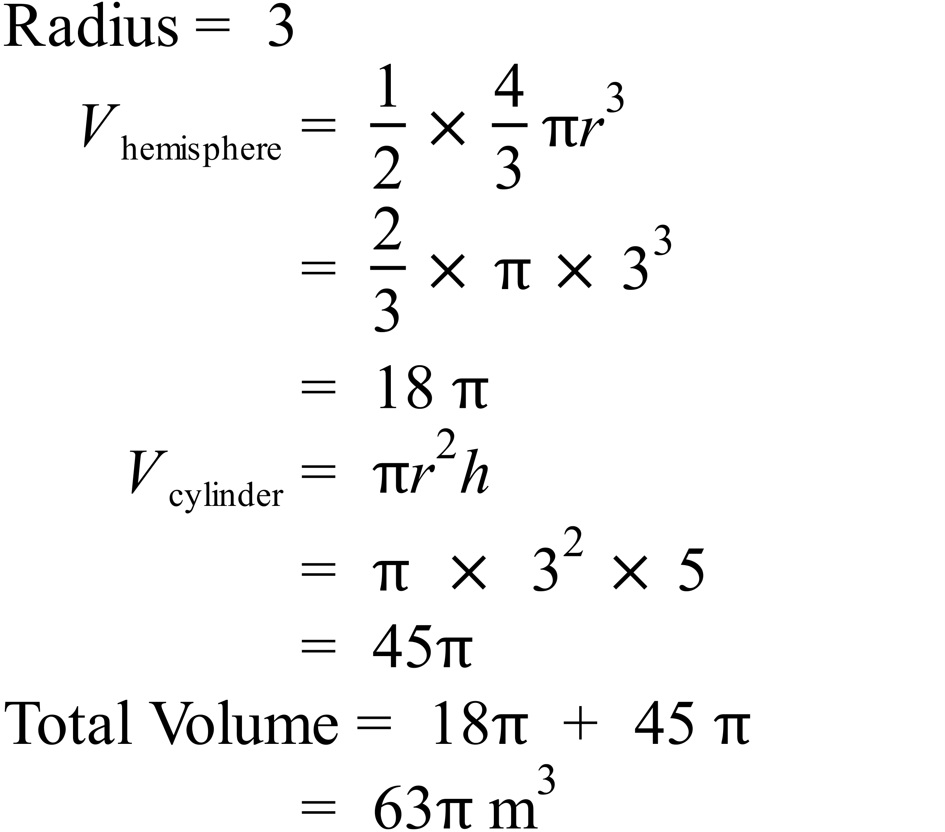 |  | 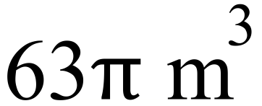
 | 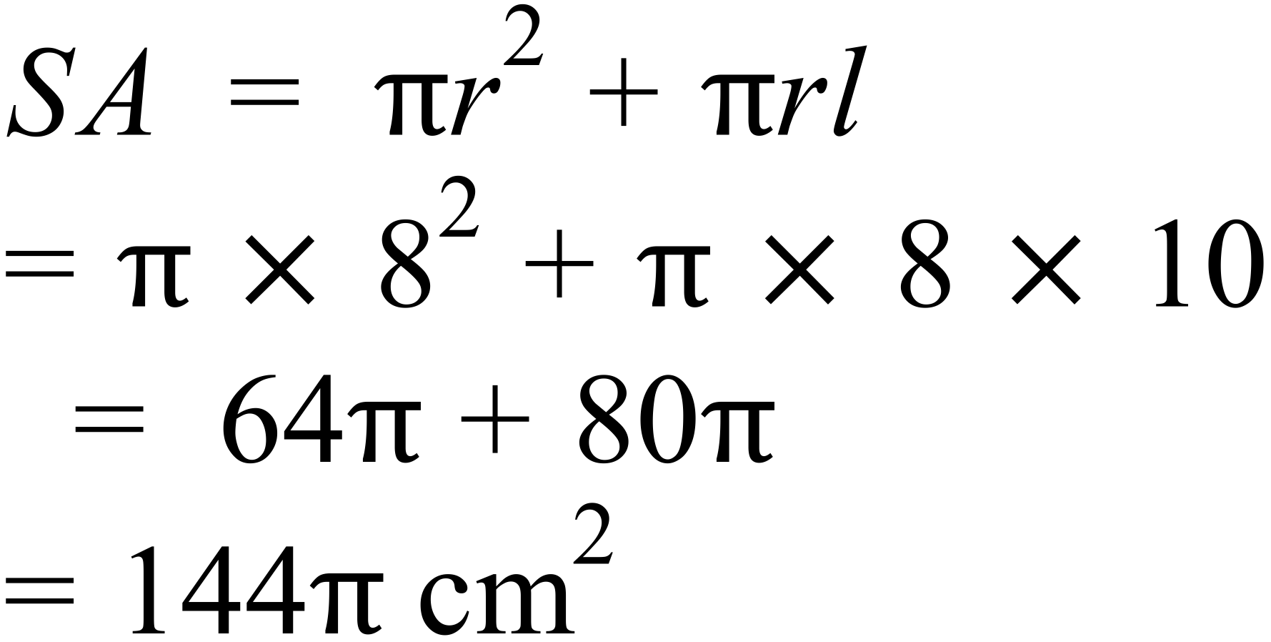 |  | 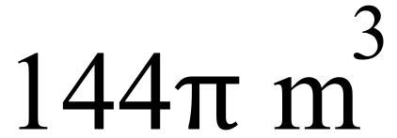
 | 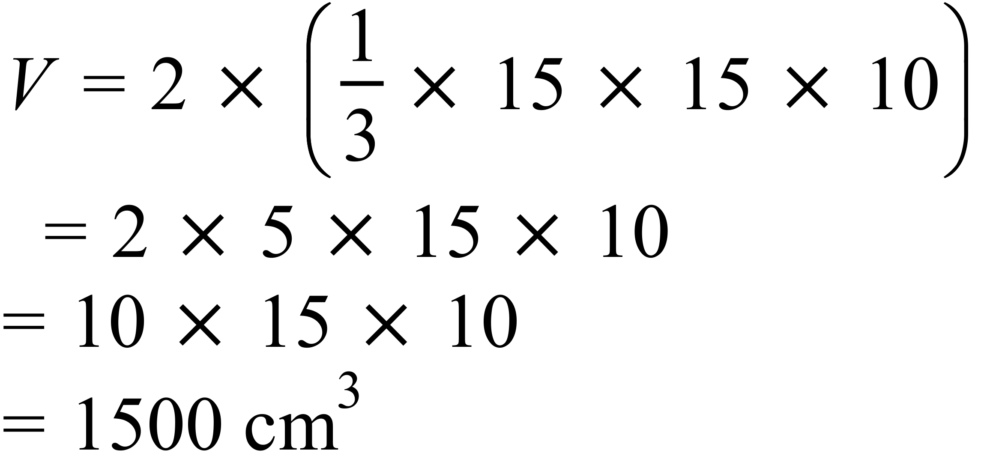 |  | 1500 cm³

Year 10 |  | Surface Area and Volume of Other Solids | Calculator Allowed
Section 2 Multiple Choice Section
ANSWERS
No. | WORKING |  |  | ANSWER
 | 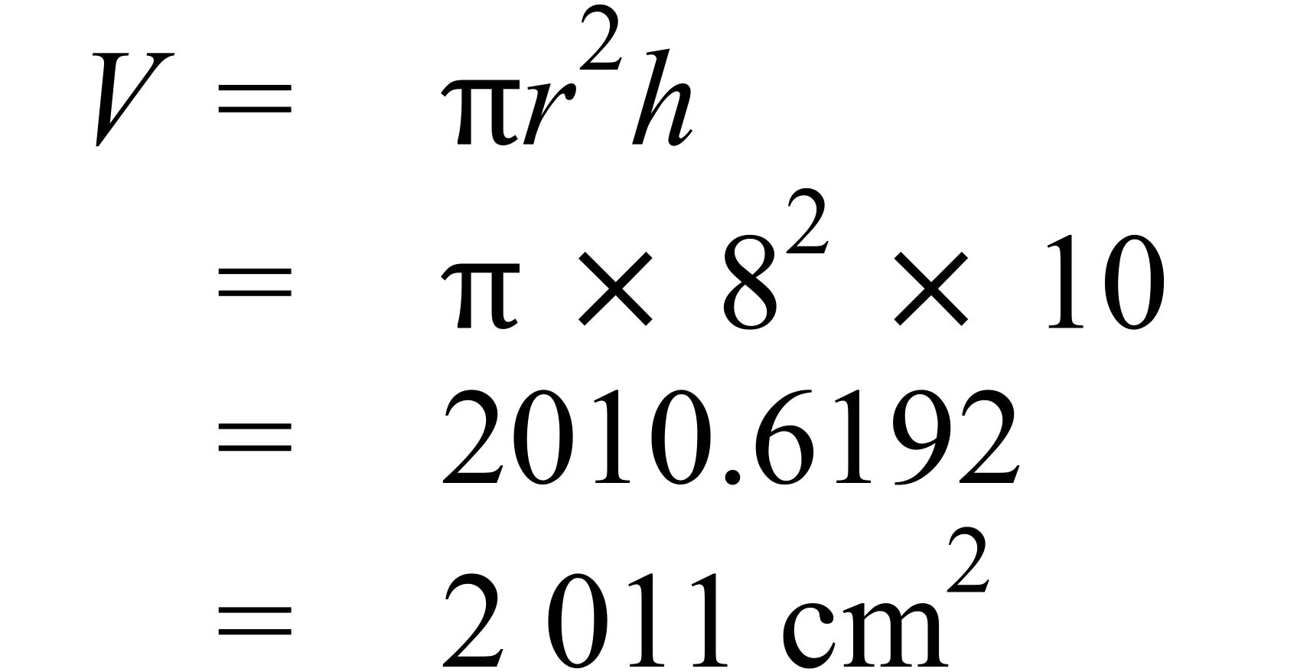 |  |  | B
 | 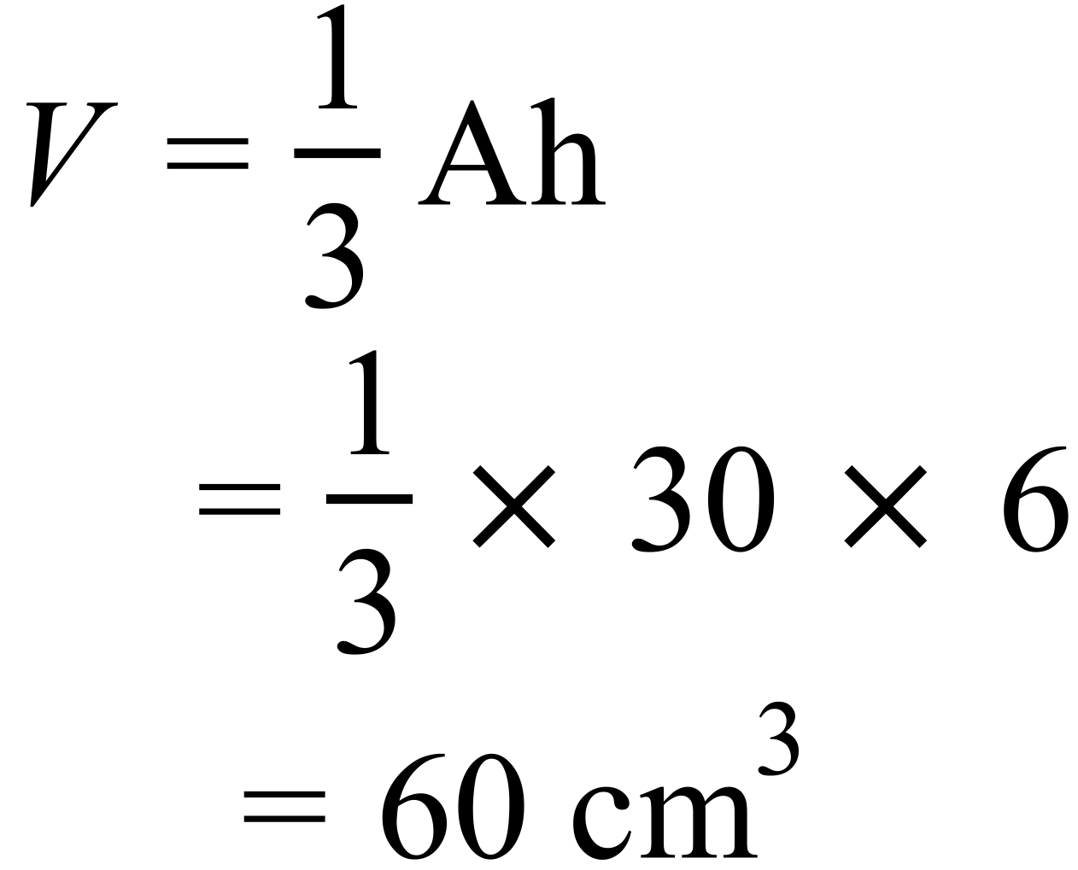 |  |  | C
 | There are 16 cubes, by counting.  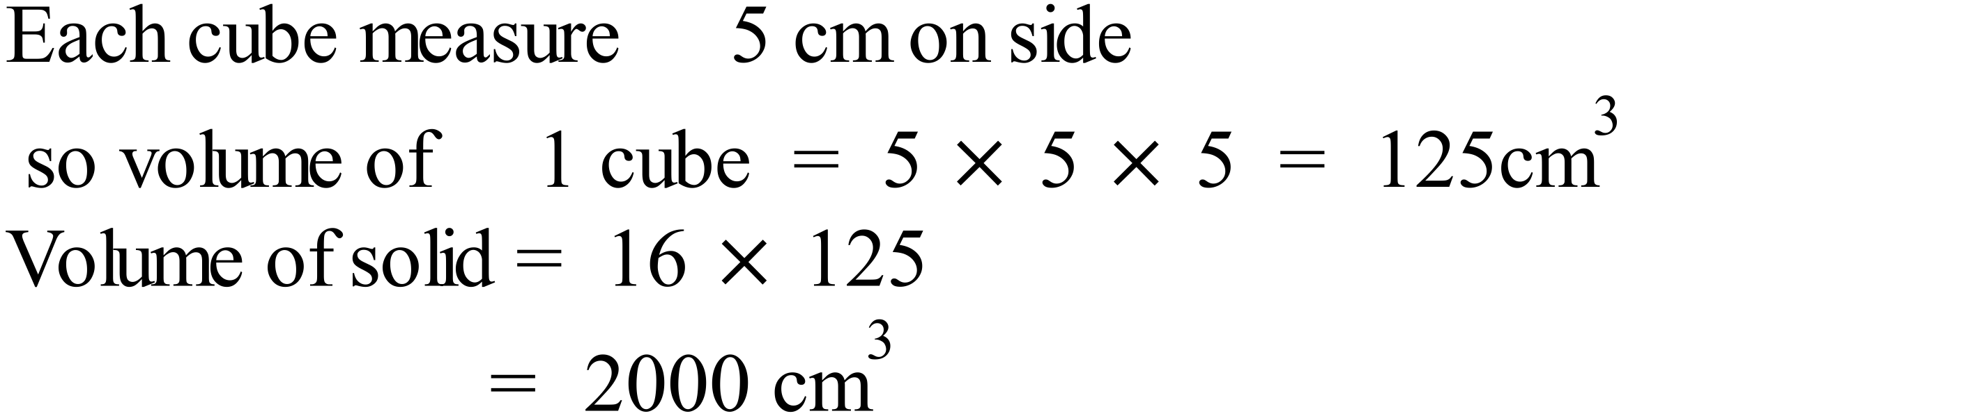 |  |  | D
 | 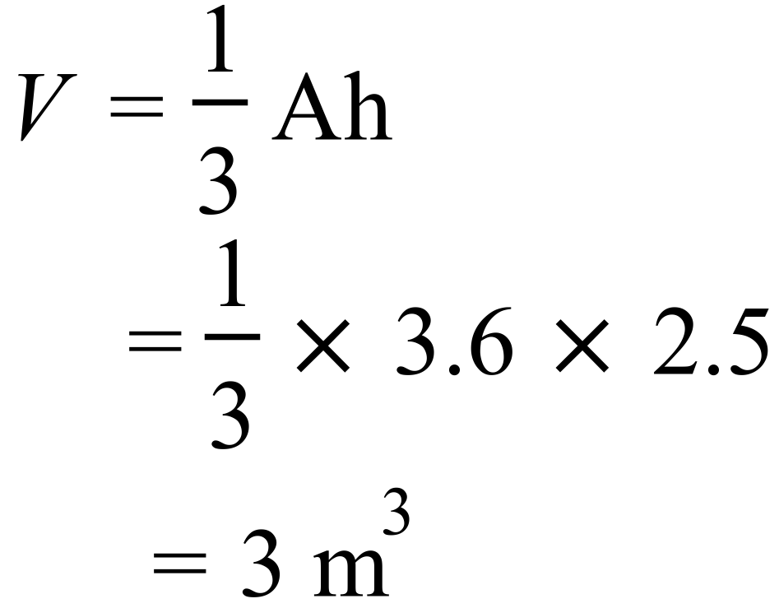 |  |  | A
 | 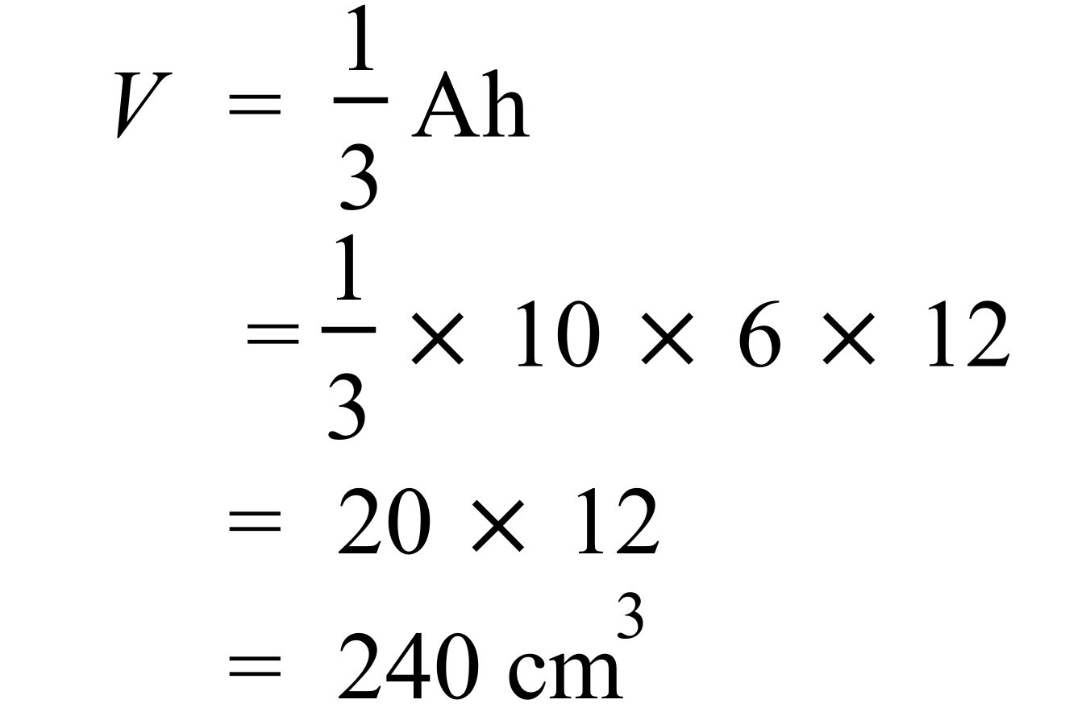 |  |  | B
 | 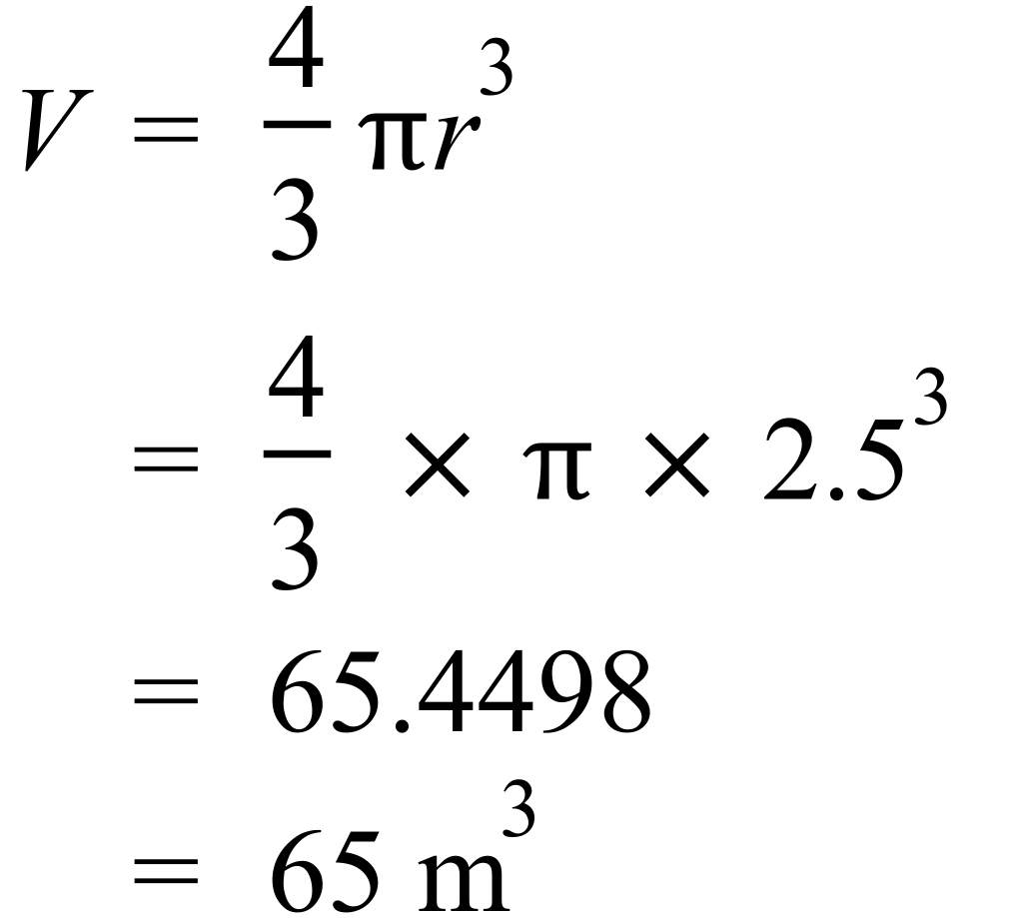 |  |  | C
 | 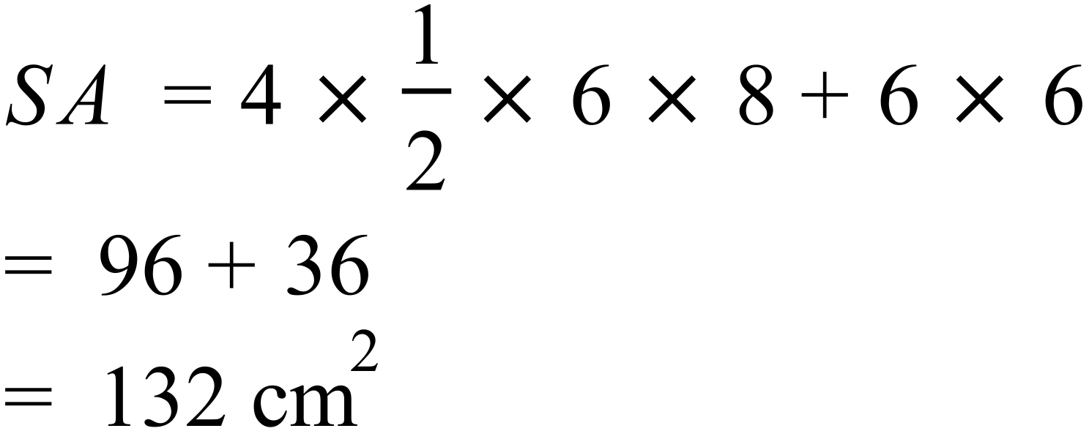 |  |  | A
 | 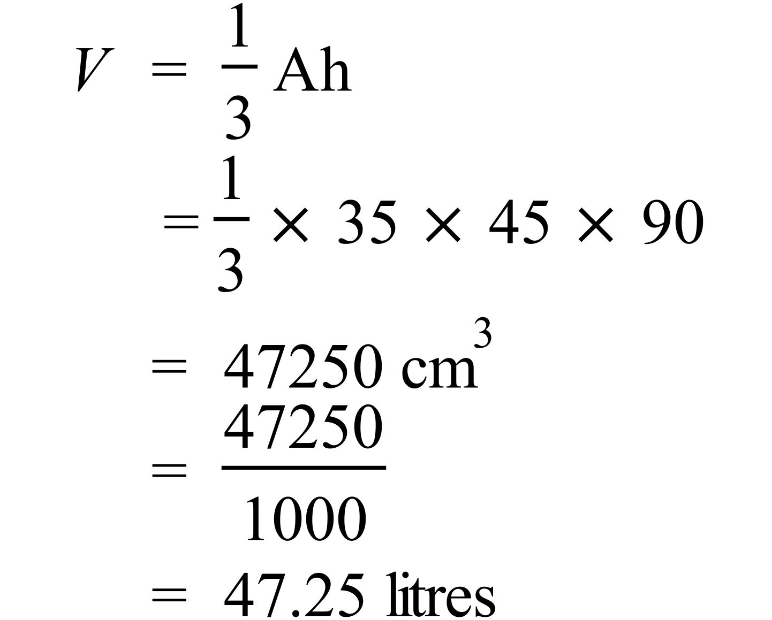 |  |  | B
 | 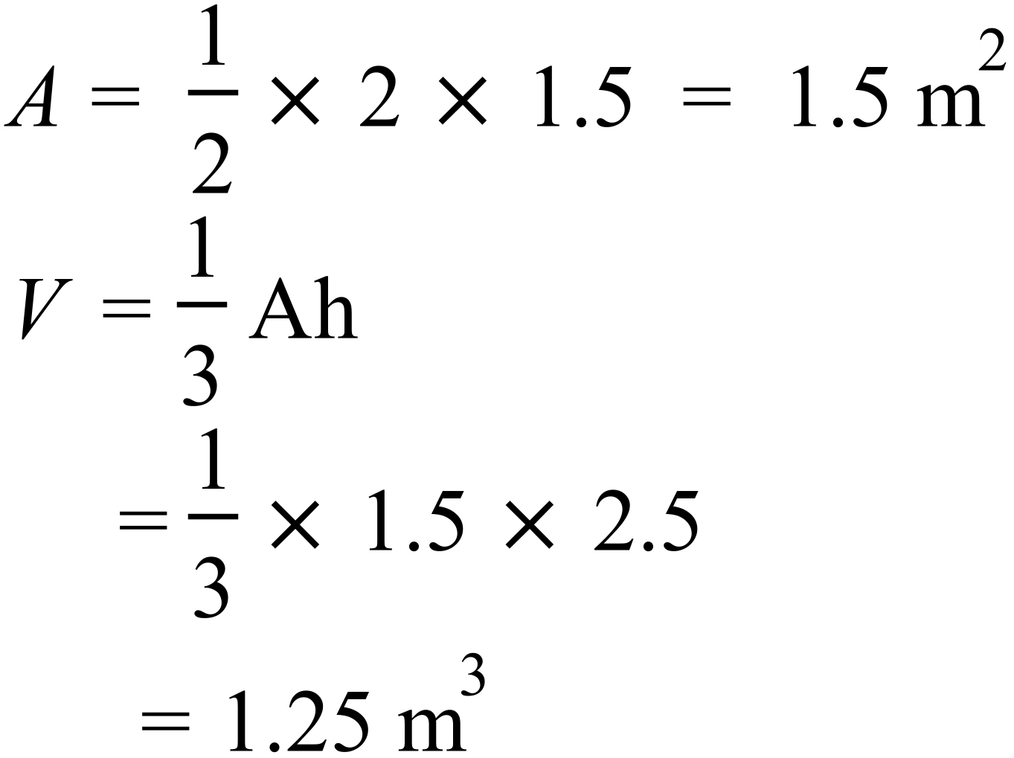 |  |  | A
 | 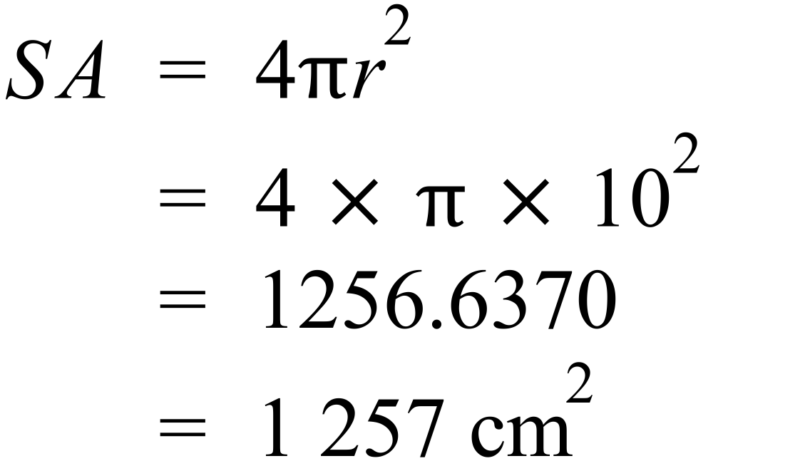 |  |  | D
 | 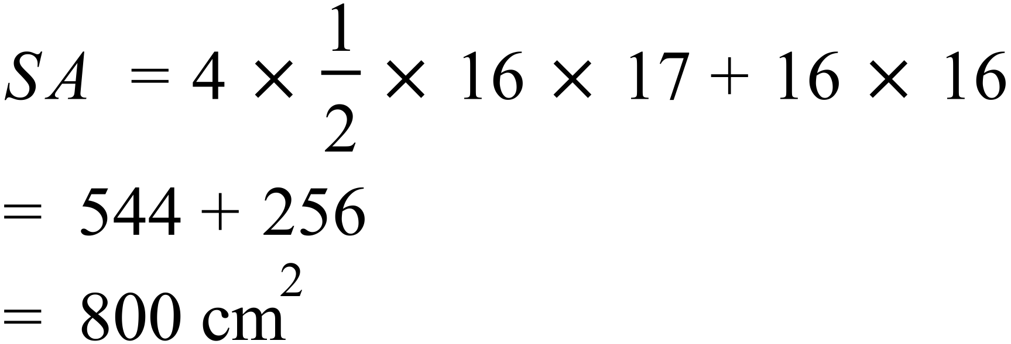 |  |  | C
 | 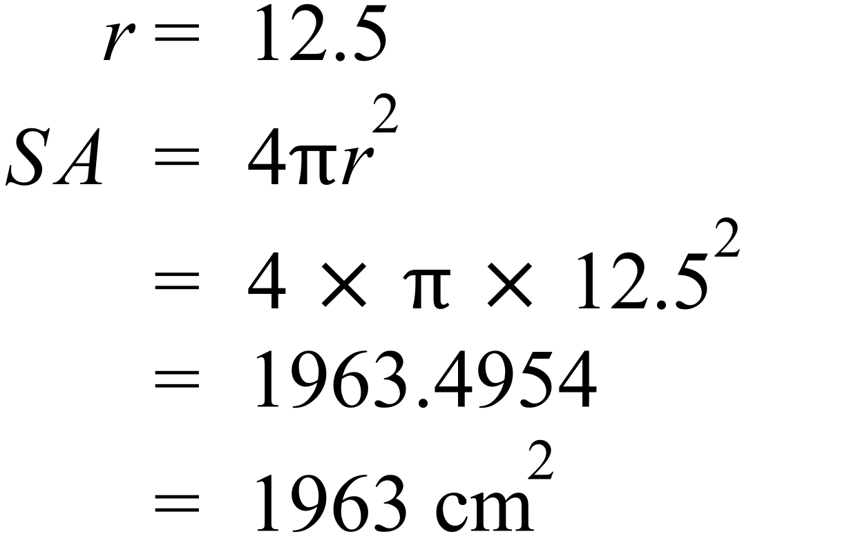 |  |  | D
 | 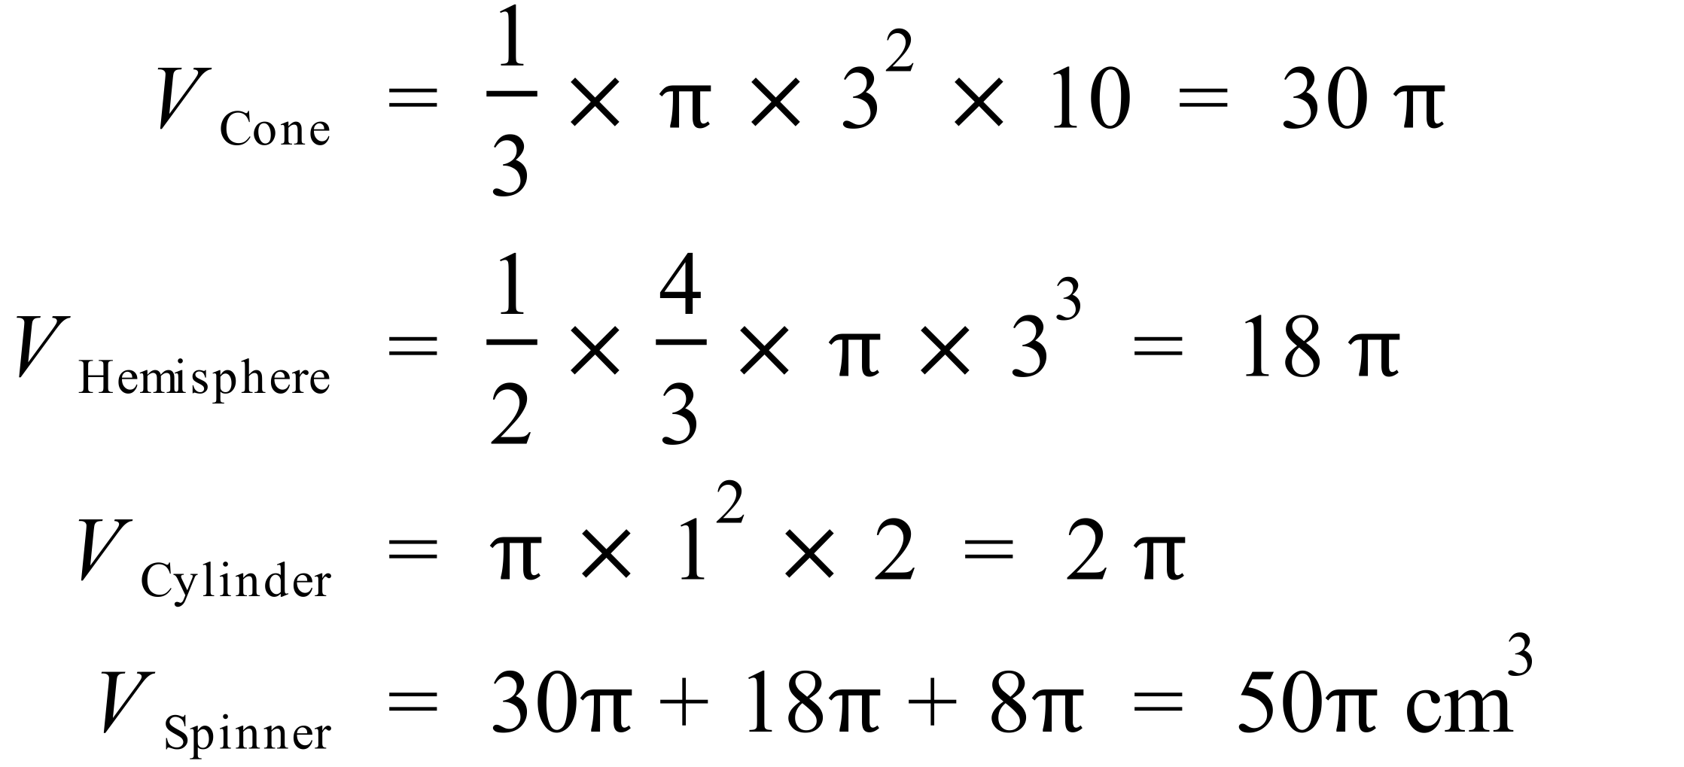 |  |  | A
 | 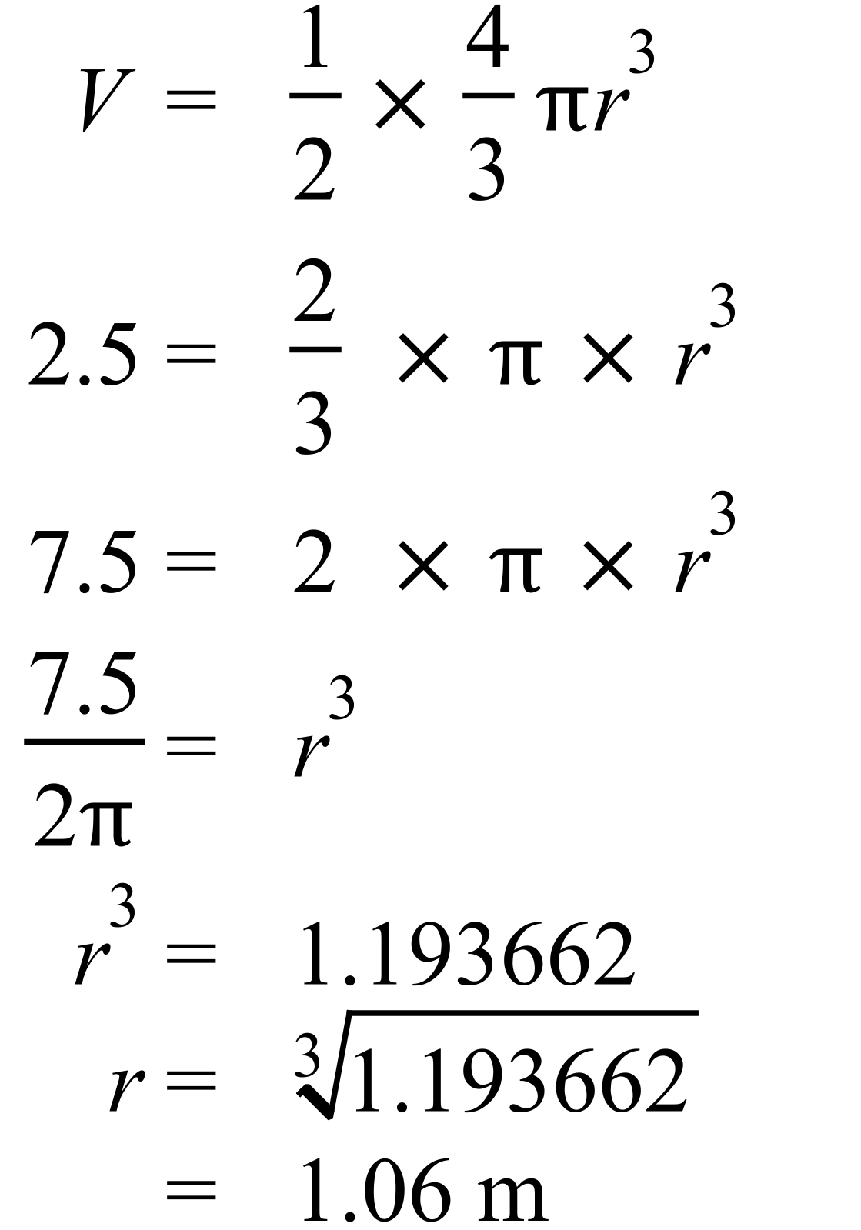 |  |  | B
 | 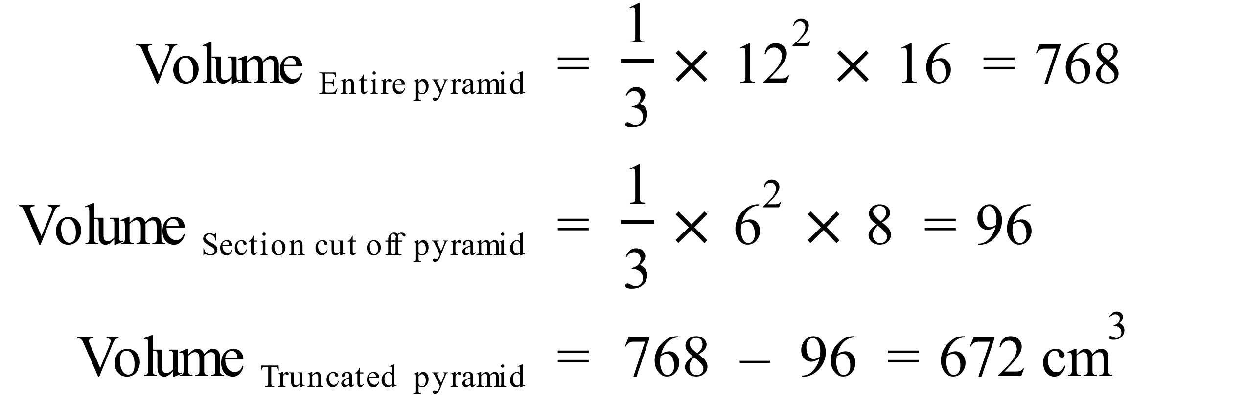 |  |  | D

Multiple Choice Answer Sheet
Surface Area and Volume of Other Solids
Name _______ANSWERS_______________________________
Completely fill the response oval representing the most correct answer.

1. A B C D
2. A B C D
3. A B C D
4. A B C D
5. A B C D
6. A B C D
7. A B C D
8. A B C D
9. A B C D
10. A B C D
11. A B C D
12. A B C D
13. A B C D
14. A B C D
15. A B C D
Year 10 |  | Surface Area and Volume of Other Solids | Calculator Allowed
Section 3 Longer Answer Section
ANSWERS
 |  |  |  | Marks
1. | (a) 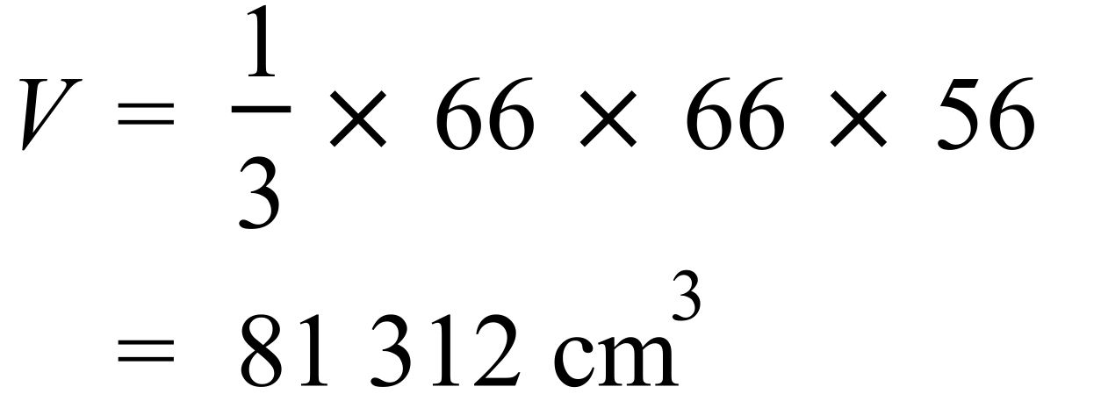 |  |  | 1
 | (b) 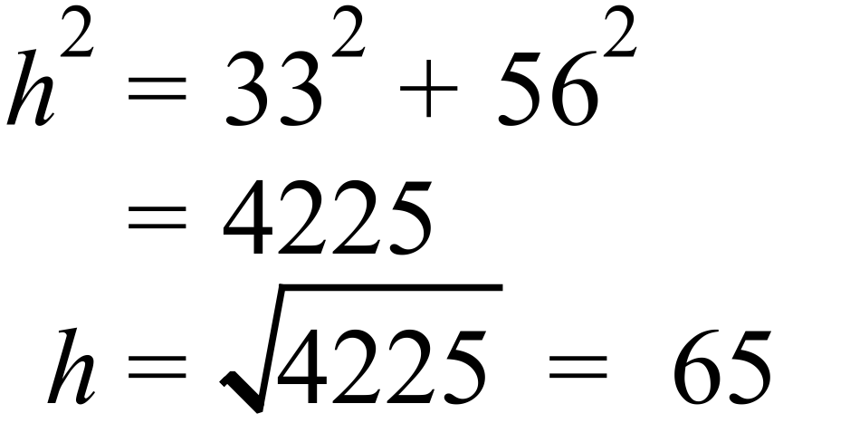 |  |  | 1
 | (c) 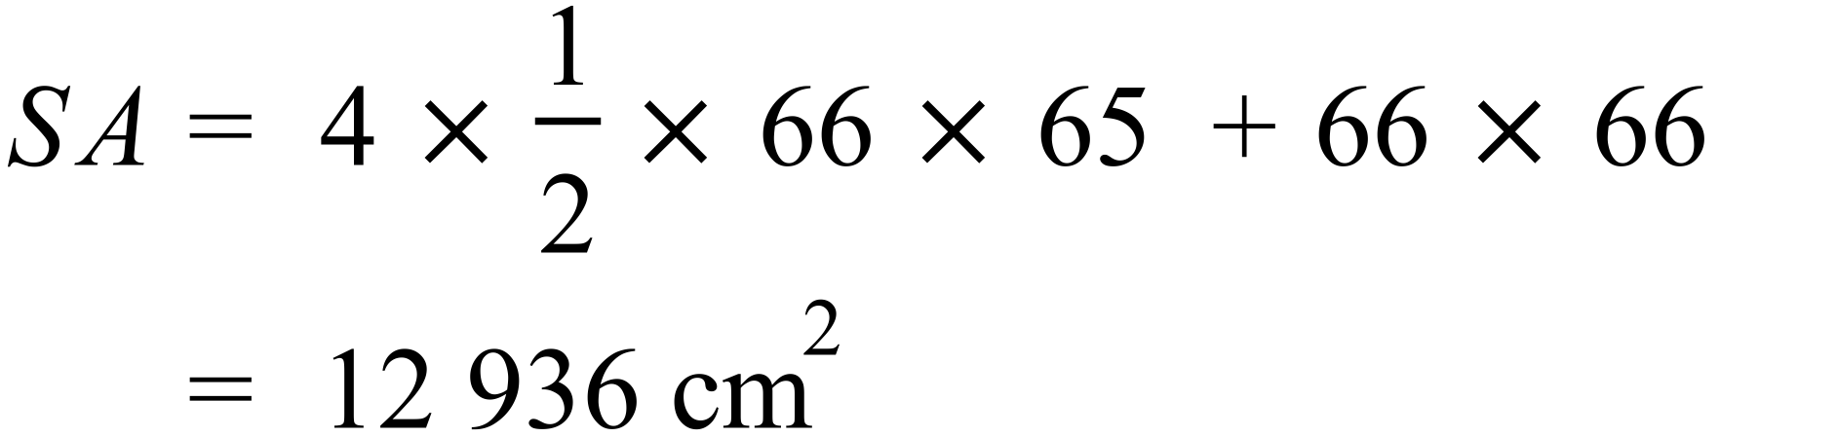 |  |  | 2

